Supplementary Information
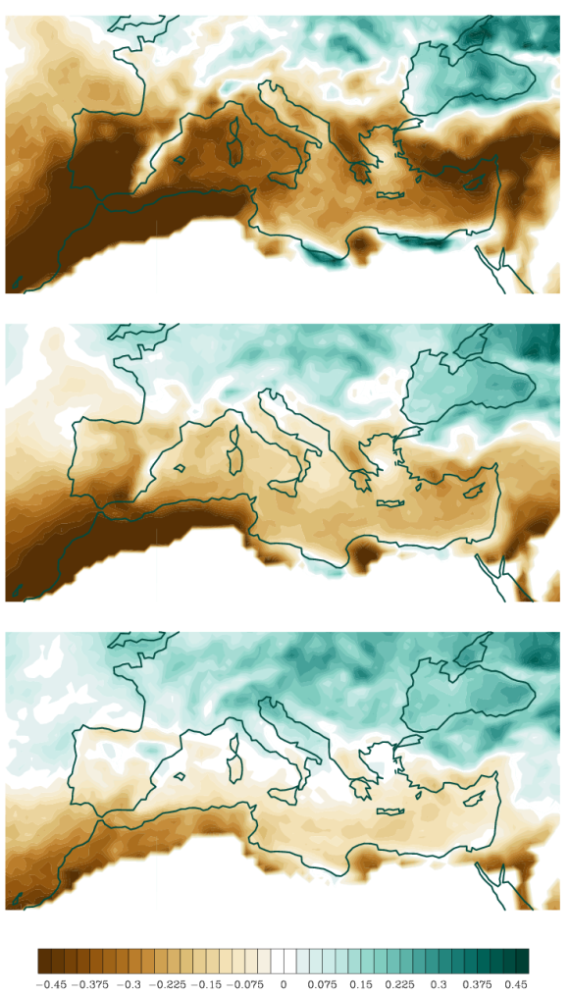
SI. Fig1 Changes in winter projections (DJF): a) 10th, b)50th and c) 90th percentile of daily precipitation rate [*100%], by 2061-2099, compared to 1961-1999. Values around the 50th percentile 0.1 [mm/day] in the present climate were masked.

