

*JGR: Oceans*

Supporting Information for

**20th Century Multivariate Indian Ocean Regional Sea Level Reconstruction**

**PraveenKumar1, Benjamin Hamlington2, Se-Hyeon Cheon2, Weiqing Han3 and Philip Thompson4**

1Center for Coastal and Physical Oceanography, Old Dominion University, Norfolk, VA, USA.

2Jet Propulsion Laboratory, California Institute of Technology, Pasadena, CA, USA.

3 Department of Atmospheric and Oceanic Sciences, University of Colorado, Boulder, CO, USA.

4Department of Oceanography, University of Hawai’i at Mānoa, Honolulu, HI, USA.

**Contents of this file**

1. Supporting Figures S1 to S3

**A. Supporting Figures**



Figure S1. List of all the tide gauge stations used as a source of historic sea level in the multivariate sea level reconstruction.

Figure S2. Data density map showing percentage of ERSSTv5 data available for **(a)** 1900-1960 and **(b)** 1960 – 2018. **(c)** Percentage of available ICOADS SLP data 1900 – 1960 and **(d)** 1960 – 2018.

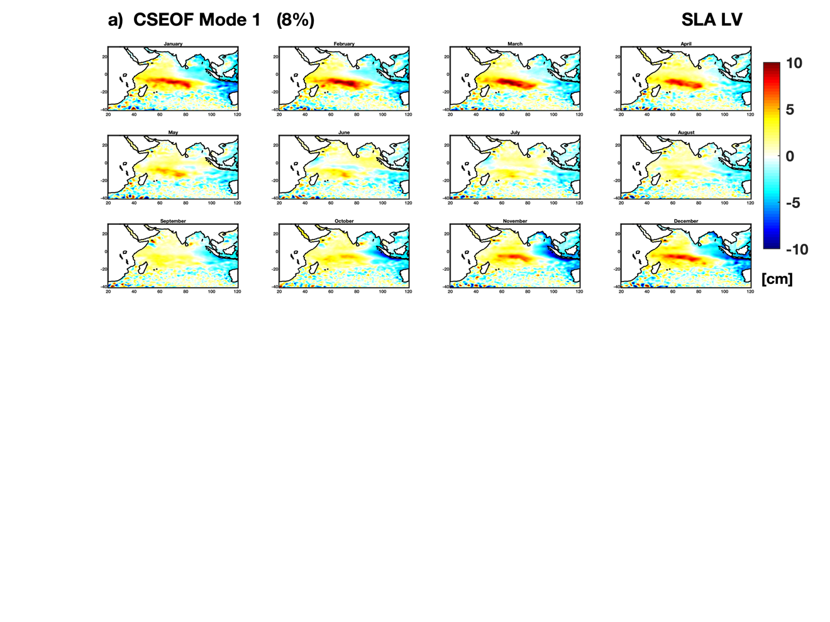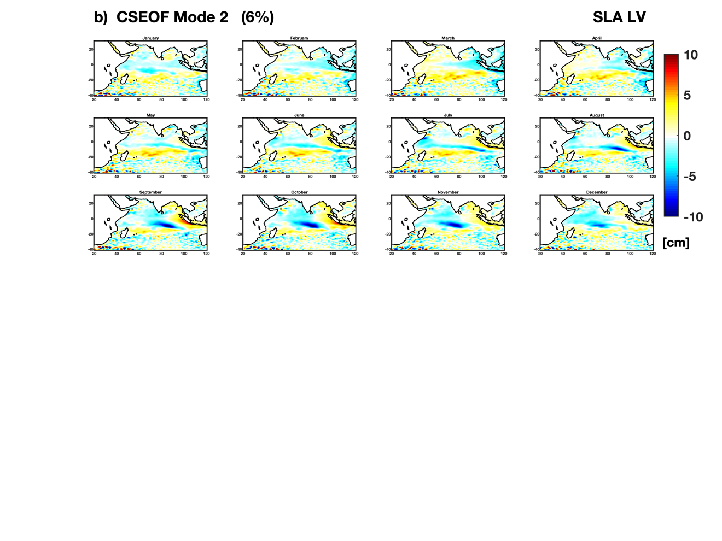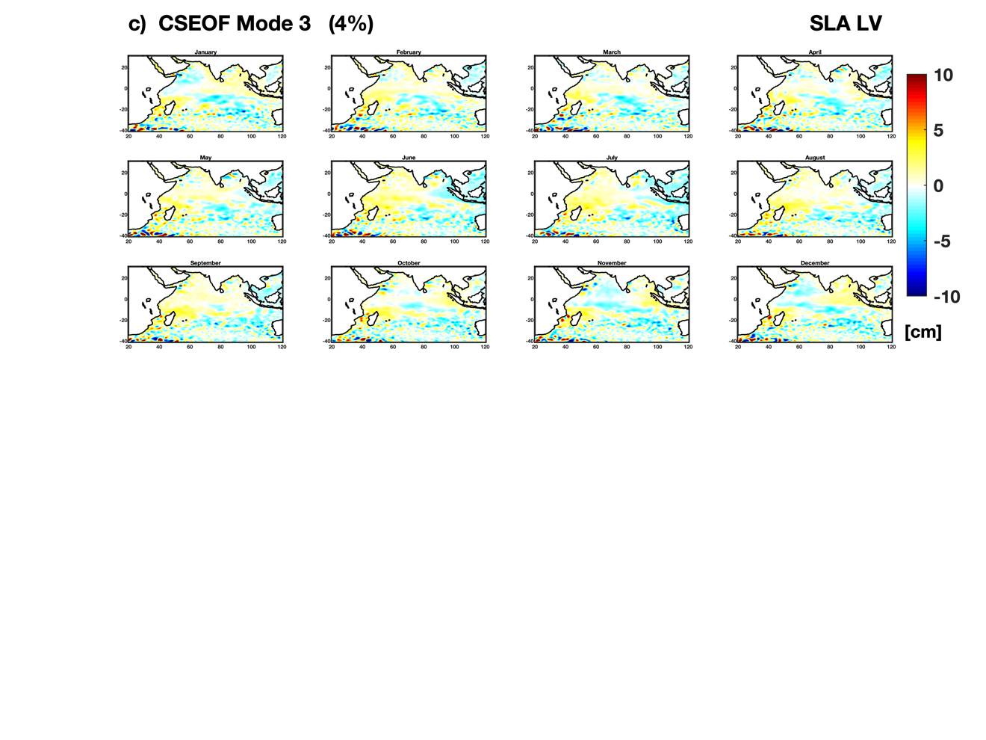

Figure S3: (a-c) LV spatial patterns for Figure 3 PCTS associated with the first three modes (not including the seasonal cycle).