Earth’s Future
Supporting Information for
Past, Present and Future Pacific Sea Level Change
B.D. Hamlington¹*, T. Frederikse¹, P.R. Thompson², J.K. Willis¹, R.S. Nerem³, J.T. Fasullo³
- Jet Propulsion Laboratory, California Institute of Technology, Pasadena, CA, USA
- University of Hawaii at Manoa, Honolulu, HI, USA.
- University of Colorado at Boulder, Boulder, CO, USA.

*Corresponding author: bhamling@jpl.nasa.gov
4800 Oak Grove Dr., Pasadena, CA, 91109
818-354-6202

© 2020. All rights reserved

Contents of this file

Text S1
Figure S1
Table S1
Table S2

Text S1
Estimation of Trends
Linear trends were estimated over different time periods using least squares. To adequately account for serial correlation of the residuals in the trend estimates, we follow the procedure from Haigh et al. (2014) and reduce the degrees of freedom to compute the uncertainty associated with the trend estimates. In the case of the 10-year trends, we subset a 10-year portion of the available record, estimate the linear trend, and then set the trend estimate at the midpoint of that 10-year record. This leads to a loss of 5 years at each end of the time series. To estimate the evolution of the full-record trend, we use a starting point of 1993 (1950 in the case of the tide gauge estimate), successively add a month of data from this starting point, and compute the linear trend with the shortened record length. This process is repeated until the last linear trend estimate is the full-record estimate from the satellite altimetry data covering the time period from 1993 to 2019.

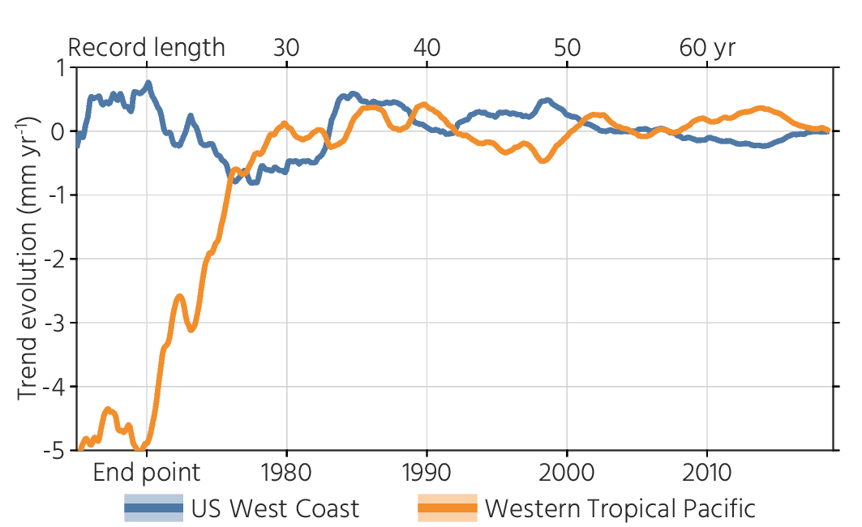
Figure S1. For the time period from 1950 to 2019, trend evolution as estimated from available tide gauge data. For this figure, the start-date for the trend evolution computation is 1950, and x-axis indicates end-date for trend estimate. The last data point is therefore the trend from 1950 to 2019 and first data point is the trend from 1950 to 1965. Full-record trend and acceleration have been removed prior to computing trend evolution.

Table S1. Information for tide gauges used in the two regions of interest. Although the time period covered by the tide gauges extends prior to 1950, but the information below covers only the time period of interest.

Tide Gauge Name | Region | Longitude | Longitude | Time Period Covered | Record Completeness (%)
San Francisco | U.S. West Coast | 237.5 | 37.8 | 1950-2019 | 100
San Diego | U.S. West Coast | 242.8 | 32.7 | 1950-2019 | 98
Los Angeles | U.S. West Coast | 241.7 | 33.7 | 1950-2019 | 98
La Jolla | U.S. West Coast | 242.7 | 32.9 | 1950-2019 | 97
Santa Monica | U.S. West Coast | 241.5 | 34.0 | 1950-2019 | 87
Crescent City | U.S. West Coast | 235.8 | 41.7 | 1950-2019 | 98
Alameda | U.S. West Coast | 237.7 | 37.7 | 1950-2019 | 99
Port San Luis | U.S. West Coast | 239.2 | 35.2 | 1950-2019 | 94
Manila | Western Tropical Pacific | 121.0 | 14.6 | 1950-2019 | 96
Cebu | Western Tropical Pacific | 123.9 | 10.3 | 1950-2019 | 85
Legaspi | Western Tropical Pacific | 123.8 | 13.2 | 1950-2019 | 93
Apra Harbor | Western Tropical Pacific | 144.7 | 13.4 | 1950-2019 | 93

Table S2: CMIP6 model runs used in this study

Model name | Reference DOI | Provides natural-forcing only historical run
ACCESS-CM2 | https://doi.org/10.22033/ESGF/CMIP6.2281
ACCESS-ESM1-5 | https://doi.org/10.22033/ESGF/CMIP6.2288 | x
CanESM5 | https://doi.org/10.22033/ESGF/CMIP6.1301 | x
CMCC-CM2-SR5 | https://doi.org/10.22033/ESGF/CMIP6.3896
CNRM-CM6-1-HR | https://doi.org/10.22033/ESGF/CMIP6.1388
CNRM-ESM2-1 | https://doi.org/10.22033/ESGF/CMIP6.1391
EC-Earth3 | https://doi.org/10.22033/ESGF/CMIP6.181
GISS-E2-1-G | https://doi.org/10.22033/ESGF/CMIP6.1400 | x
IPSL-CM6A-LR | https://doi.org/10.22033/ESGF/CMIP6.1534 | x
MIROC6 | https://doi.org/10.22033/ESGF/CMIP6.881
MPI-ESM1-2-HR | https://doi.org/10.22033/ESGF/CMIP6.741
MPI-ESM1-2-LR | https://doi.org/10.22033/ESGF/CMIP6.742
MRI-ESM2 | https://doi.org/10.22033/ESGF/CMIP6.621
NorESM2-LM | https://doi.org/10.22033/ESGF/CMIP6.604 | x
NorESM2-MM | https://doi.org/10.22033/ESGF/CMIP6.506
UKESM1-0-LL | https://doi.org/10.22033/ESGF/CMIP6.2245

