Supporting information for…

Multi-model precipitation responses to removal of U.S. sulfur dioxide emissions

D.M. Westervelt^{1,5}, A.J. Conley², A.M. Fiore^{1,3}, J.-F. Lamarque², D. Shindell^{4,5}, M. Previdi¹, G. Faluvegi^{5,6}, G. Correa¹, L.W. Horowitz⁷
¹Lamont-Doherty Earth Observatory, Columbia University. Palisades, New York, USA ²National Center for Atmospheric Research, Boulder. Colorado, USA ³Department of Earth and Environmental Sciences, Columbia University, New York, New York, USA ⁴Nicholas School of the Environment, Duke University. Durham, NC, USA ⁵NASA Goddard Institute for Space Studies, New York, New York, USA ⁶National Oceanic and Atmospheric Administration, Geophysical Fluid Dynamics Laboratory, Princeton, NJ, USA

Corresponding author: Daniel Westervelt (danielmw@ldeo.columbia.edu)

Table 1: Region definitions
Region (Abbr.) | Lon. range | Lat. range
South Australia (S Aus) | 110E-180E | 50S-28S
North Australia (N Aus) | 110E-155E | 28S-10S
Central America (C Amer) | 115W-85W | 10N-30N
Western North America (W N Amer) | 130W-105W | 30N-60N
Central North America (C N Amer) | 105W-85W | 30N-50N
Eastern North America (E N Amer) | 85W-60W | 25N-50N
Alaska (Alaska) | 170W-105W | 60N-70N
Mediterranean Basin (Med) | 10W-40E | 30N-50N
Northern Europe (N Euro) | 10W-40E | 50N-75N
South Asia (S Asia) | 65E-100E | 5N-30N
Central Asia (C Asia) | 40E-75E | 30N-50N
North Asia (N Asia) | 40E-180E | 50N-70N
Arctic | 180W-180E | 60N-90N
Niño3.4 | 170W-120W | 5S-5N
Sahel | 20W-40E | 10N-20N

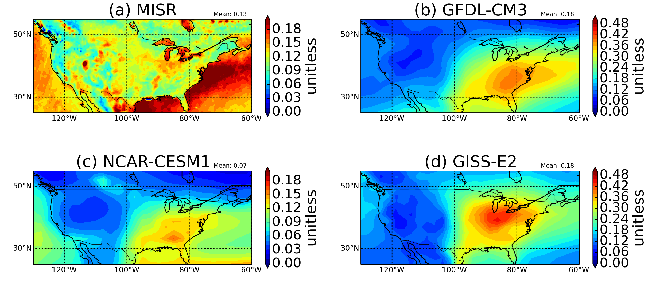
Figure 1: Annual mean all-sky AOD (550 nm) over the U.S. in (a) MISR (2001-2011 mean) and each of the three models: (b) GFDL-CM3, (c) NCAR-CESM1, and (d) GISS-E2. Note different scale for GFDL-CM3 and GISS-E2.

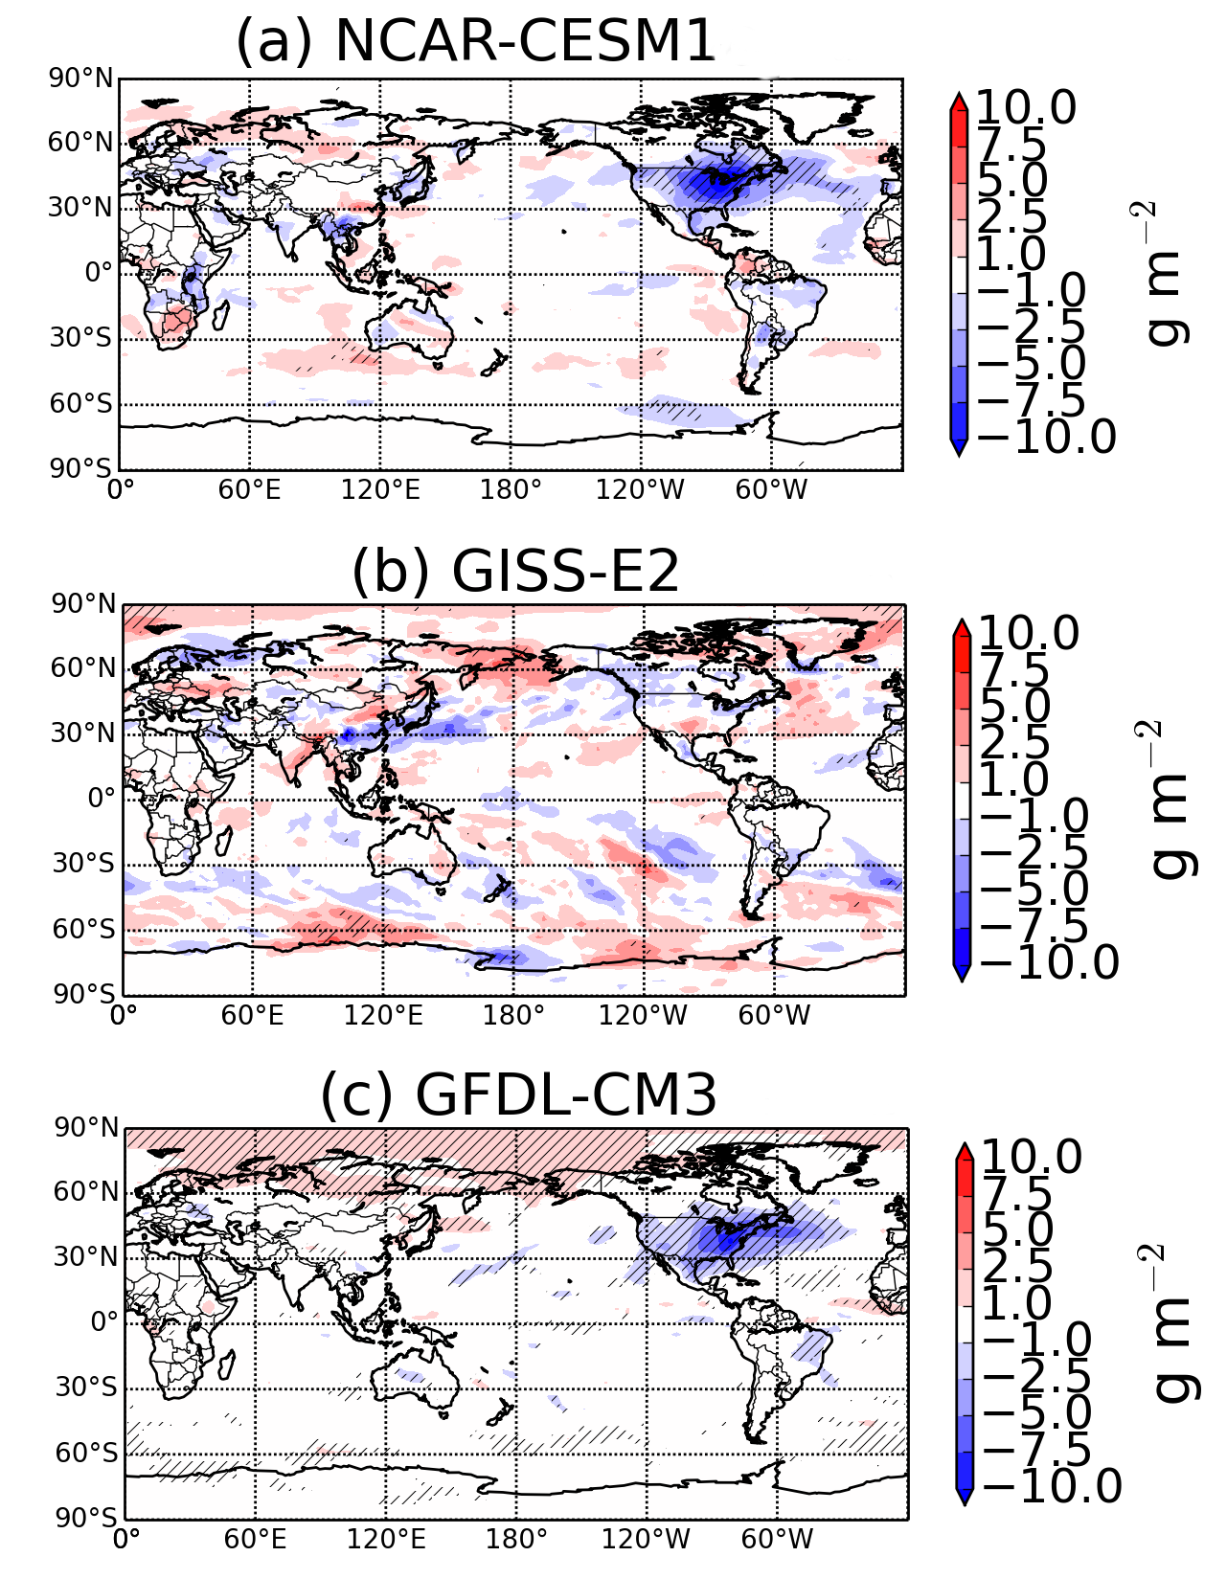
Figure 2: Response of global cloud liquid water path (LWP) to zero US SO₂ emissions for (a) NCAR-CESM1, (b) GISS-E2, and (c) GFDL-CM3. Hatching represents statistical significance at the 95% confidence level

Figure 3: Annual mean surface temperature response to zero US SO₂ emissions in CESM1. Hatching represents statistical significance at 95% confidence levels according to a Student’s t-test.

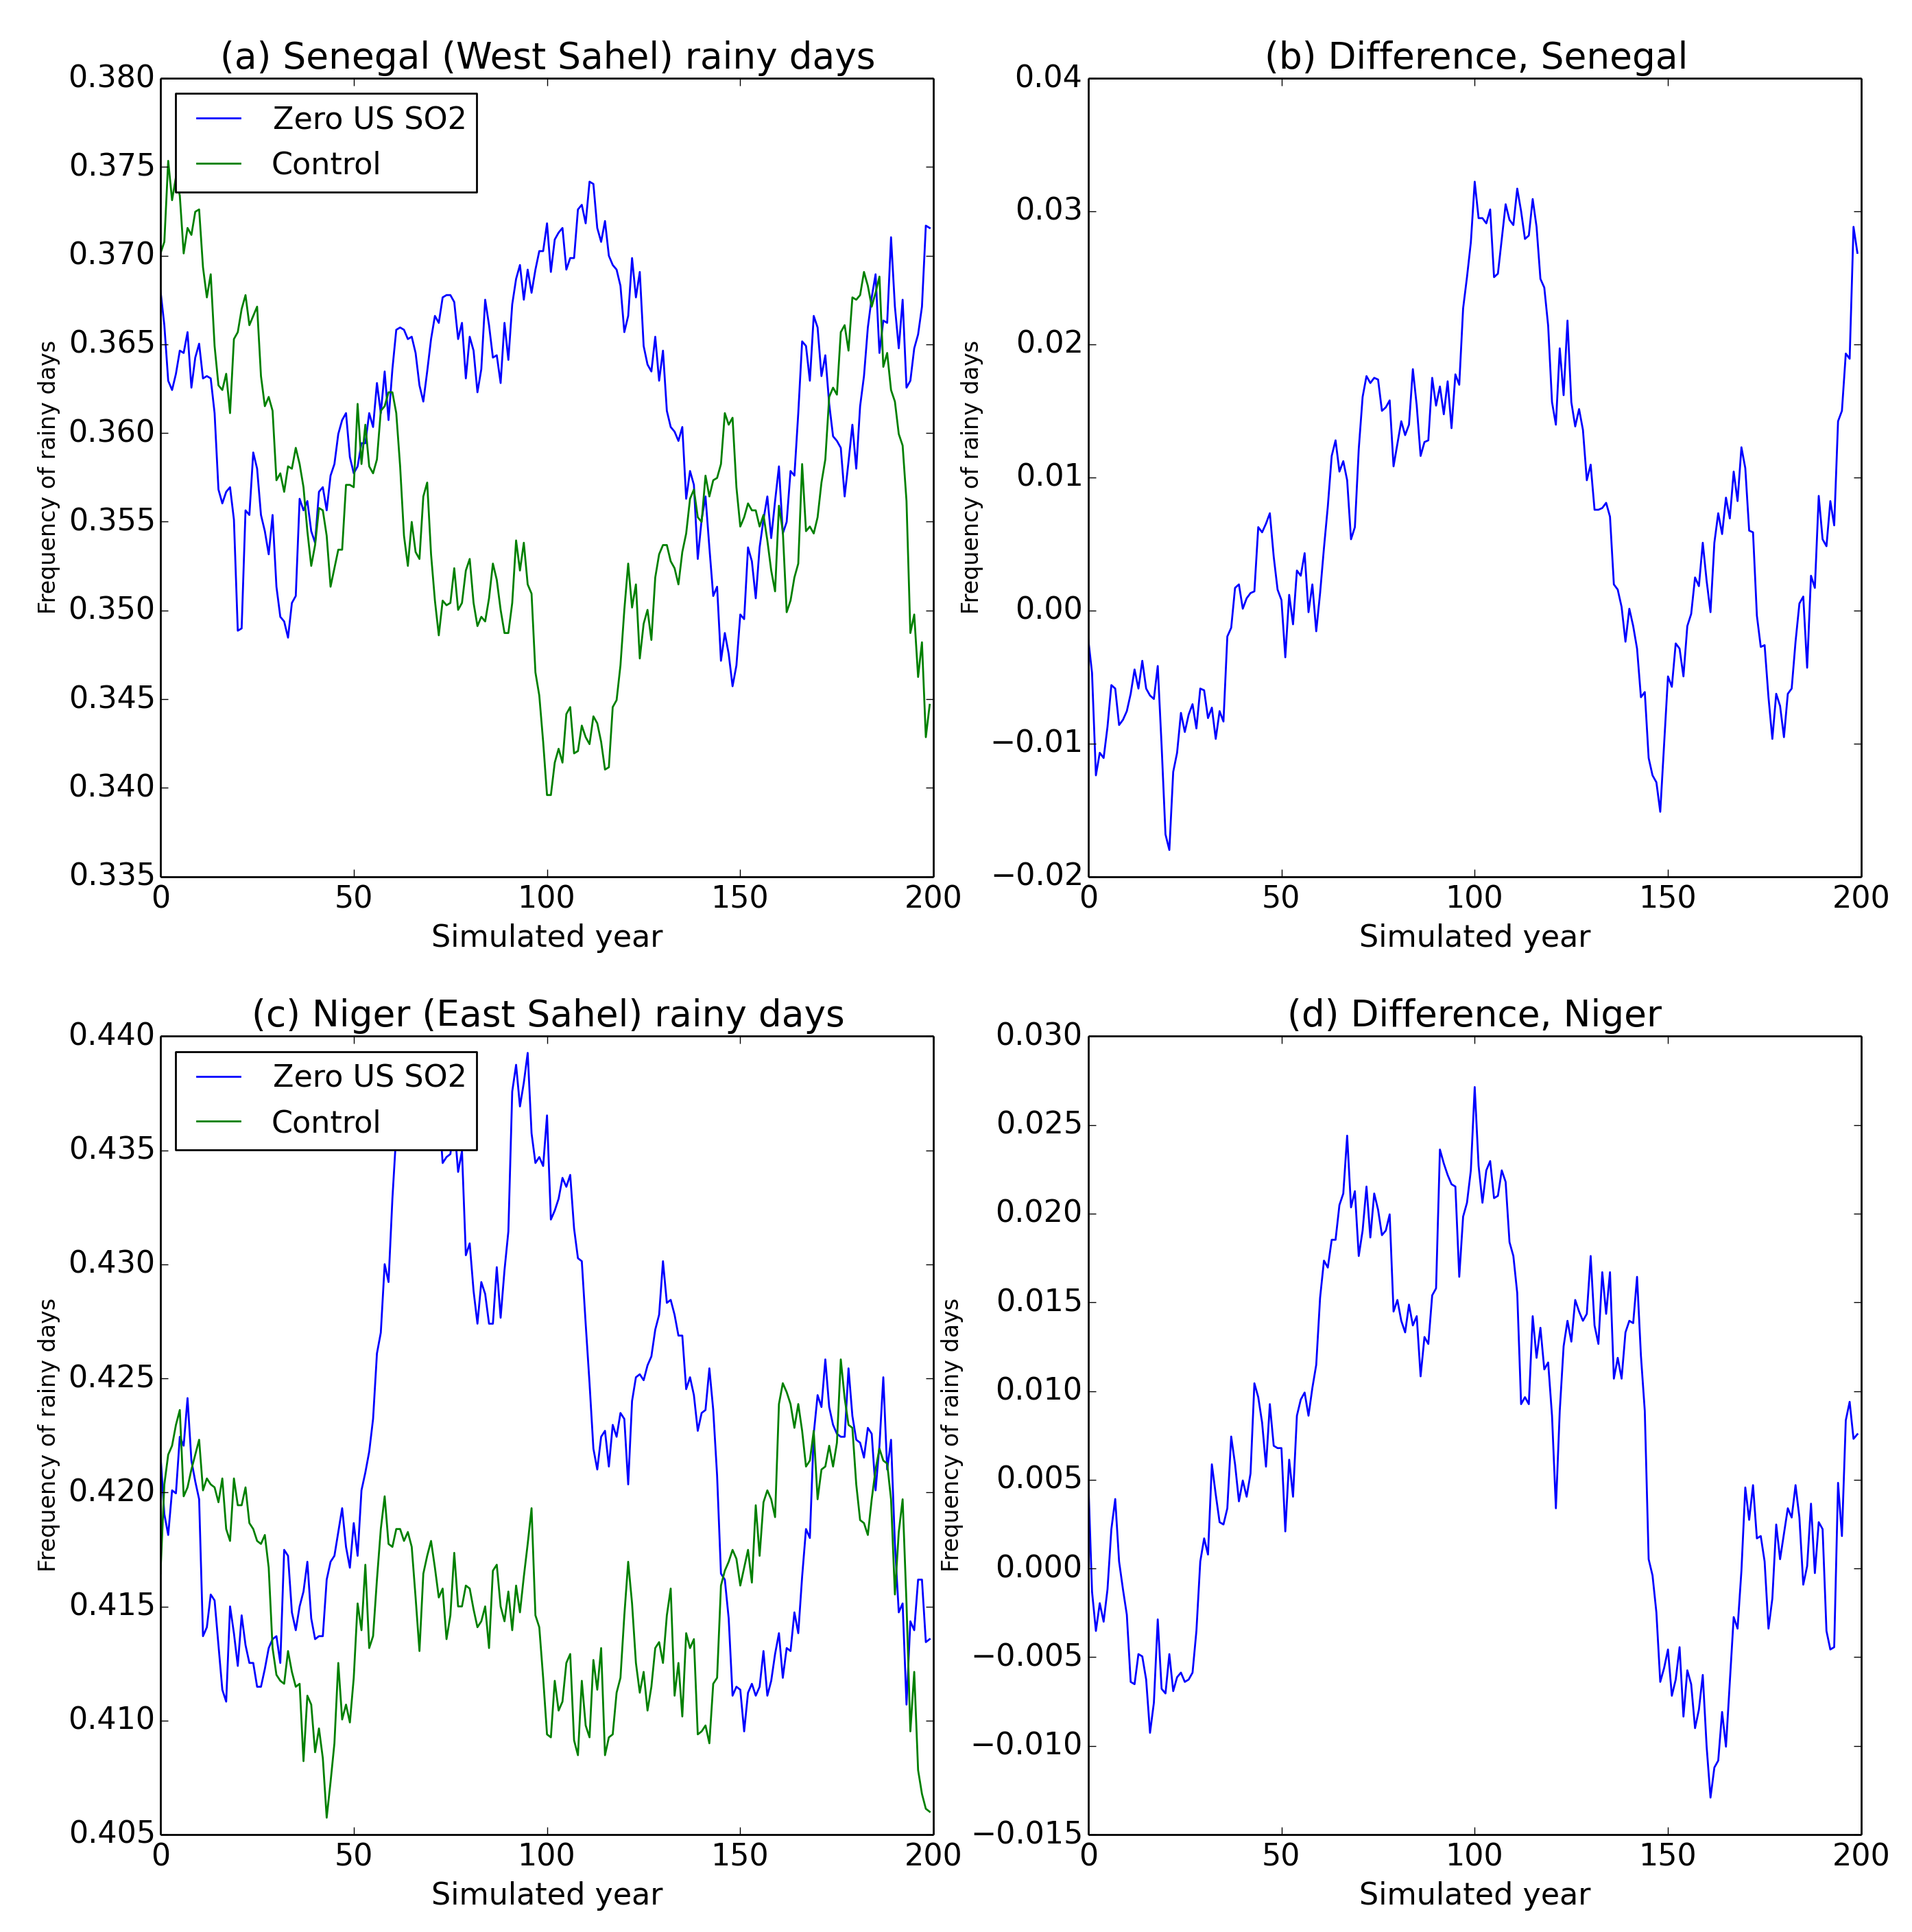
Figure 4: Frequency of rainy days in GFDL-CM3 in a given year in two Sahelian nations: (a) Senegal and (c) Niger. Differences between the perturbation run and control shown in (b) and (d) for each nation

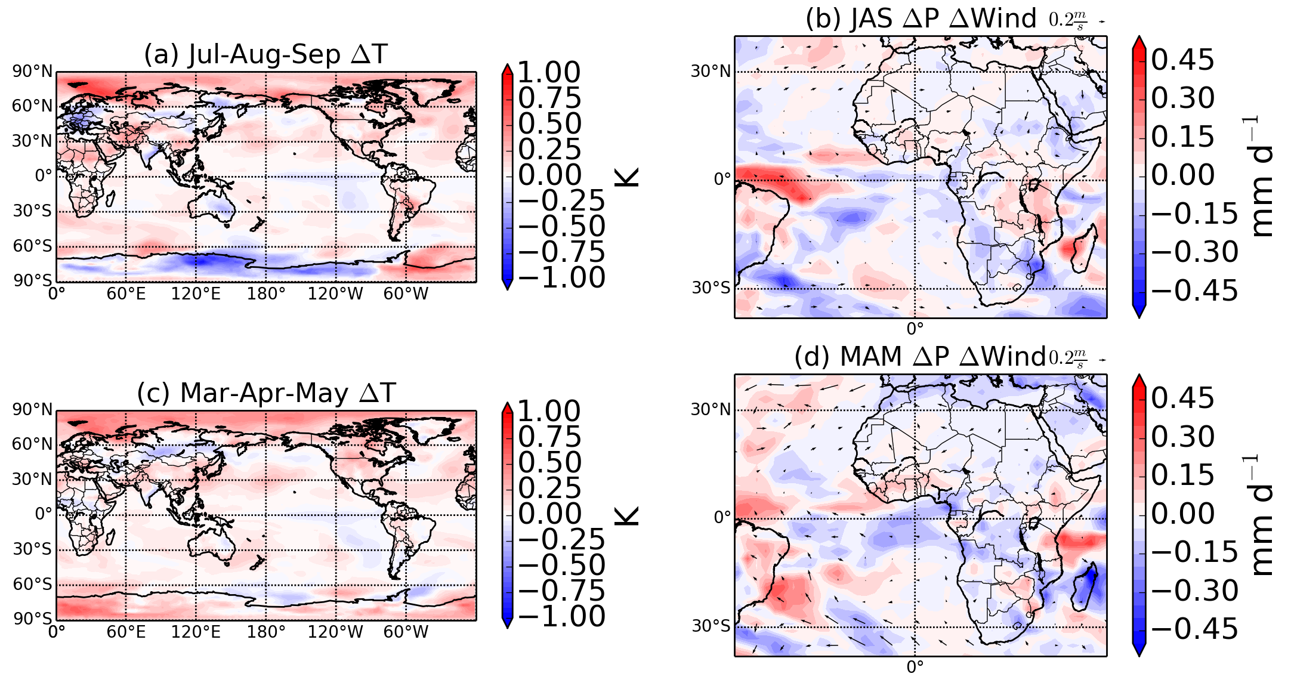
Figure 5: (a) GISS-E2 JAS temperature difference between perturbation and control. (b) GISS-E2 JAS precipitation and wind difference between perturbation and control. (c) Same as (a), but for MAM. (d) Same as (b), but for MAM

