Journal of Geophysical Research: Atmospheres
Supporting Information for
Large-Scale Atmospheric Circulation Patterns Associated with US Great Plains Warm Season Droughts Revealed by Self-Organizing Maps
Yizhou Zhuang¹, Rong Fu², and Hongqing Wang¹
¹Department of Atmospheric and Oceanic Sciences, School of Physics, Peking University, Beijing, China.
²Department of Atmospheric and Oceanic Sciences, University of California, Los Angeles, Los Angeles, California, USA.

Contents of this file

Figures S1 to S3
Tables S1 to S5

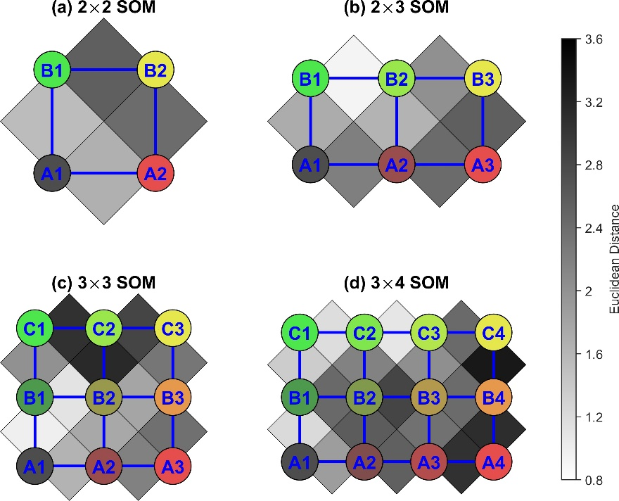
Figure S1. Node organizations corresponding to four SOM schemes shown in Fig. 1. Nodes are named according to their locations in the grid: numbers represent columns from left to right and upper-case letters represent rows from bottom to top. Colors inside the circles represent different nodes and are the same as Fig. 1. Node connections are marked as blue lines. The greyscale color between adjacent nodes indicates the distance between them: lighter color means shorter distance or stronger connection and darker color means longer distance or weaker connection.

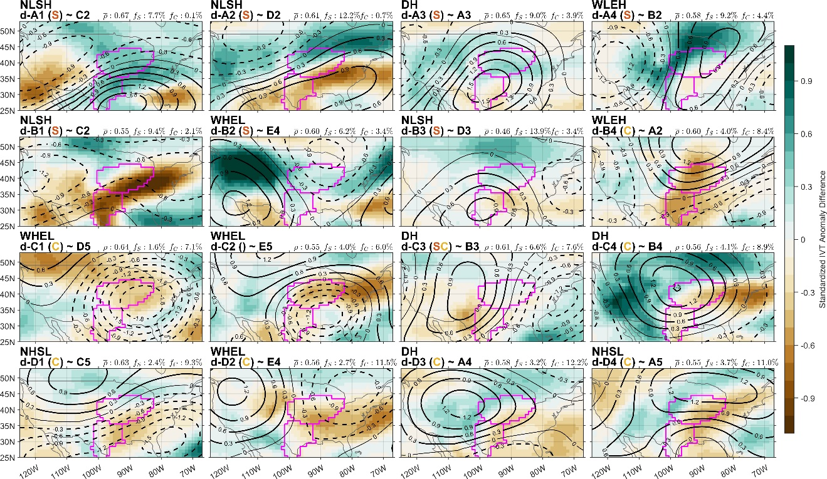
Figure S2. Same as Fig. 6 in the paper, but for the variable difference (Z500′ and IVT′) between each node in the 4×4 SOM and its counterpart in the 5×5 SOM.

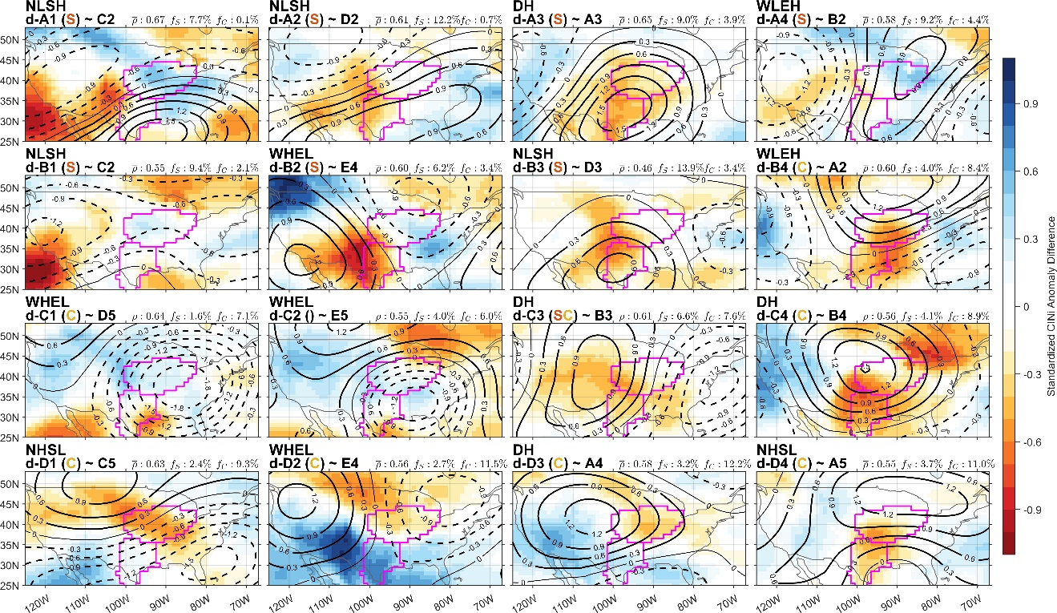
Figure S3. Same as Fig. 7 in the paper, but for the variable difference (Z500′ and CINi′) between each node in the 4×4 SOM and its counterpart in the 5×5 SOM.

Table S1. SOM training performance comparison between schemes without and with PCA-preprocessing (5×5 SOM for all samples, 1000 epochs). Each scheme is run for 30 times and the mean value and standard deviation of the training time (unit: s), quantization error (QE), mean correlation coefficient (${\overline{ρ}}^{*}$), and maximum correlation coefficient between any two nodes (CC_{max}) are listed.
Input | No PCA | PCA: 99% | PCA: 90% | PCA: 80% | PCA: 70%
No. of PC | / | 172/22/207 | 37/8/39 | 20/6/19 | 13/4/12
Input size | 5967×5133 | 5967×401 | 5967×84 | 5967×45 | 5967×29
Training time | 484.8±5.9 | 8.5±0.3 | 8.1±0.2 | 6.4±0.2 | 5.5±0.3
QE | 0.693±0.000 | 0.693±0.000 | 0.695±0.000 | 0.697±0.000 | 0.702±0.001
$${\overline{ρ}}^{*}$$ | 0.550±0.001 | 0.549±0.001 | 0.547±0.001 | 0.543±0.001 | 0.528±0.002
CC_{max} | 0.662±0.025 | 0.656±0.023 | 0.664±0.018 | 0.682±0.021 | 0.738±0.023

Table S2. SOM training performance comparison for all samples. Quantization error (QE), mean correlation coefficient (${\overline{ρ}}^{*}$), and maximum correlation coefficient between any two nodes (CC_{max}) are listed.
Node Scheme | 2×3 | 3×3 | 3×4 | 4×4 | 4×5 | 5×5 | 5×6
QE | 0.751 | 0.736 | 0.724 | 0.713 | 0.704 | 0.695 | 0.687
$${\overline{ρ}}^{*}$$ | 0.438 | 0.474 | 0.498 | 0.516 | 0.531 | 0.548 | 0.558
CC_{max} | 0.230 | 0.505 | 0.493 | 0.598 | 0.644 | 0.686 | 0.702

Table S3. Same as Table S2, but for SOM with very dry days.
Node Scheme | 2×2 | 2×3 | 3×3 | 3×4 | 4×4 | 4×5 | 5×5
QE | 0.778 | 0.757 | 0.737 | 0.723 | 0.710 | 0.697 | 0.685
$${\overline{ρ}}^{*}$$ | 0.465 | 0.506 | 0.542 | 0.560 | 0.582 | 0.596 | 0.613
CC_{max} | 0.259 | 0.422 | 0.538 | 0.619 | 0.678 | 0.682 | 0.700

Table S4. The nodes of 5×5 SOM of all the days during our analysis period (Fig. 4) that have the maximum correlation with the nodes of the 4×4 SOM of very dry days (Fig. 6). Correlation coefficients are shown in the parenthesis. The bold font indicates the correlation coefficients that are significant at the 0.05 level. For each node in Fig. 4 & 5, the node with largest correlation coefficient in Fig. 7 & 8 is defined as its counterpart. Nodes with significantly negative $\overline{P_{C}^{'}}$ or $\overline{P_{S}^{'}}$ are labeled with a “C” or “S” next to it, respectively.
Node in 4×4 SOM | Most Correlated Nodes in 5×5 SOM | Node in 4×4 SOM | Most Correlated Nodes in 5×5 SOM
d-A1 (S) | C2 (0.83), D2 (0.81) | d-C1 (C) | D5 (0.91), C3 (0.63)
d-A2 (S) | D2 (0.84), D1 (0.81) | d-C2 | E5 (0.87), C5 (0.68)
d-A3 (S) | A3 (0.96), D2 (0.47) | d-C3 (SC) | B3 (0.96), A4 (0.53)
d-A4 (S) | B2 (0.89), A1 (0.76) | d-C4 (C) | B4 (0.67), A3 (0.62)
d-B1 (S) | C2 (0.84), C3 (0.79) | d-D1 (C) | C5 (0.91), D5 (0.70)
d-B2 | E4 (0.79), E2 (0.78) | d-D2 (C) | E4 (0.82), D5 (0.73)
d-B3 (S) | D3 (0.85), A3 (0.64) | d-D3 (C) | A4 (0.91), B4 (0.72)
d-B4 (C) | A2 (0.91), B3 (0.54) | d-D4 (C) | A5 (0.93), B5 (0.55)

Table S5. Top 8 drought years for SGP and CGP. Parameters T_{start}, T_{end}, N, $ΣP$, $\overline{P}$, N_{D}, and N_{VD} are start date, end date, duration, cumulative precipitation anomaly, daily mean precipitation anomaly, number of dry days, and number of very dry days for a drought event, respectively. The order of year is based on sum of cumulative precipitation anomaly of all drought events in the year.
Region | Year | T_{start} | T_{end} | N (d) | $ΣP$ (mm) | $\overline{P}$ (mm/d) | N_{D} (d) | N_{VD} (d)
SGP | 1998 | 04/01 | 08/02 | 124 | -209.13 | -1.69 | 81 | 56
 | 2011 | 05/01 | 06/19 | 50 | -101.86 | -2.04 | 31 | 29
 |  | 06/26 | 08/31 | 67 | -93.38 | -1.39 | 42 | 24
 | 2005 | 04/01 | 05/25 | 55 | -84.86 | -1.54 | 38 | 25
 |  | 06/03 | 07/12 | 40 | -62.59 | -1.56 | 24 | 9
 | 1980 | 05/23 | 08/06 | 76 | -124.17 | -1.63 | 46 | 33
 | 2000 | 06/22 | 08/31 | 71 | -106.71 | -1.50 | 47 | 28
 | 2002 | 04/12 | 06/26 | 76 | -96.65 | -1.27 | 41 | 20
 | 2012 | 05/15 | 07/06 | 53 | -88.31 | -1.67 | 33 | 17
 | 2003 | 04/01 | 06/02 | 63 | -81.39 | -1.29 | 37 | 24
CGP | 1988 | 04/07 | 07/12 | 97 | -196.49 | -2.03 | 79 | 62
 | 2012 | 05/07 | 08/23 | 109 | -192.99 | -1.77 | 88 | 51
 | 1980 | 04/12 | 05/13 | 32 | -71.47 | -2.23 | 27 | 22
 |  | 06/06 | 08/02 | 58 | -72.21 | -1.25 | 33 | 14
 | 1992 | 04/24 | 07/01 | 69 | -99.80 | -1.45 | 41 | 22
 | 1994 | 05/04 | 06/19 | 47 | -69.92 | -1.49 | 37 | 14
 |  | 07/21 | 08/26 | 37 | -22.66 | -0.61 | 15 | 1
 | 1983 | 07/04 | 08/31 | 59 | -89.74 | -1.52 | 44 | 29
 | 2005 | 04/12 | 05/09 | 28 | -37.48 | -1.34 | 16 | 12
 |  | 06/16 | 07/22 | 37 | -46.46 | -1.26 | 20 | 11
 | 1989 | 04/07 | 05/17 | 41 | -74.14 | -1.81 | 36 | 26

