The East Asian Subtropical Jet Stream and Atlantic Tropical Cyclones

Wei Zhang^{1,*}, Gabriele Villarini¹, Gabriel A. Vecchi^{2,3}

Supporting Information

¹IIHR-Hydroscience & Engineering, The University of Iowa, Iowa City, Iowa
²Department of Geosciences, Princeton University, Princeton, NJ, USA
³Princeton Environmental Institute, Princeton University, Princeton, NJ, USA

^{Corresponding author:}
Wei Zhang, email: wei-zhang-3@uiowa.edu

Table S1 Correlation between the frequency of Atlantic TCs, hurricanes during ASON and EASJ during JASO for 1980-2018 by controlling the Niño3.4 index during JASO. The symbol “*” denotes values that are significant at the 0.05 level.
Correlation |  | Atlantic TCs | Hurricanes
NCEP/NCAR |  | -0.58* | -0.38*
MERRA2 |  | -0.58* | -0.40*
ERA5 |  | -0.56* | -0.38*
JRA-55 |  | -0.57* | -0.40*

Table S2 Correlation between Atlantic TCs/hurricanes and 200-hPa zonal winds in different latitudes (JASO).
Correlation | Atlantic TCs (1980-2018) | Atlantic Hurricanes (1980-2018)
EASJ (30°N -35°N) | -0.70 | -0.57
EASJ (35°N -40°N) | -0.52 | -0.40
EASJ (40°N -45°N) | -0.15 | -0.10
EASJ (45°N -50°N) | 0.38 | 0.32

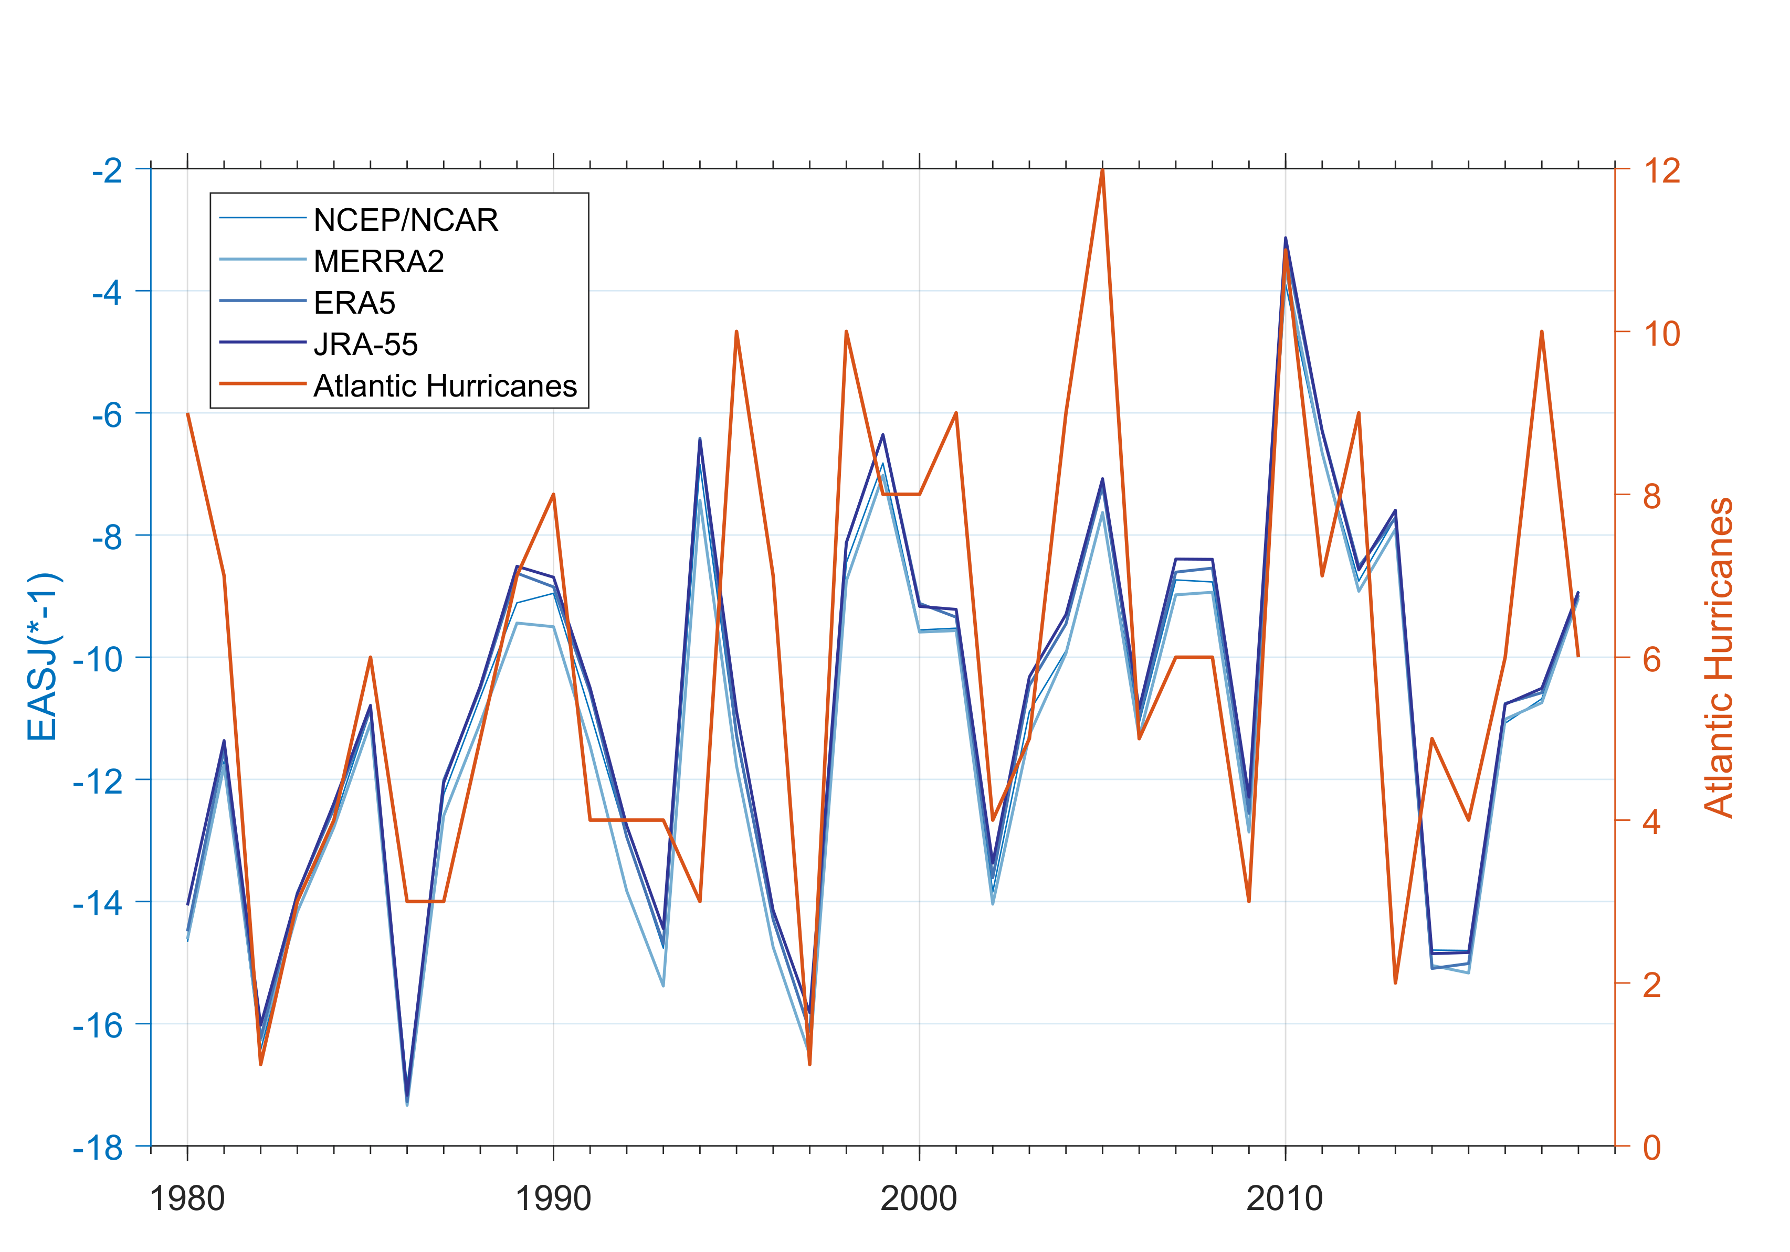
Figure S1. Frequency of Atlantic hurricanes (orange; right y-axis) for August-November of 1980-2018 and the intensity of EASJ indices (blue; left y-axis) during July-October in four different reanalysis products (see Methods for details).
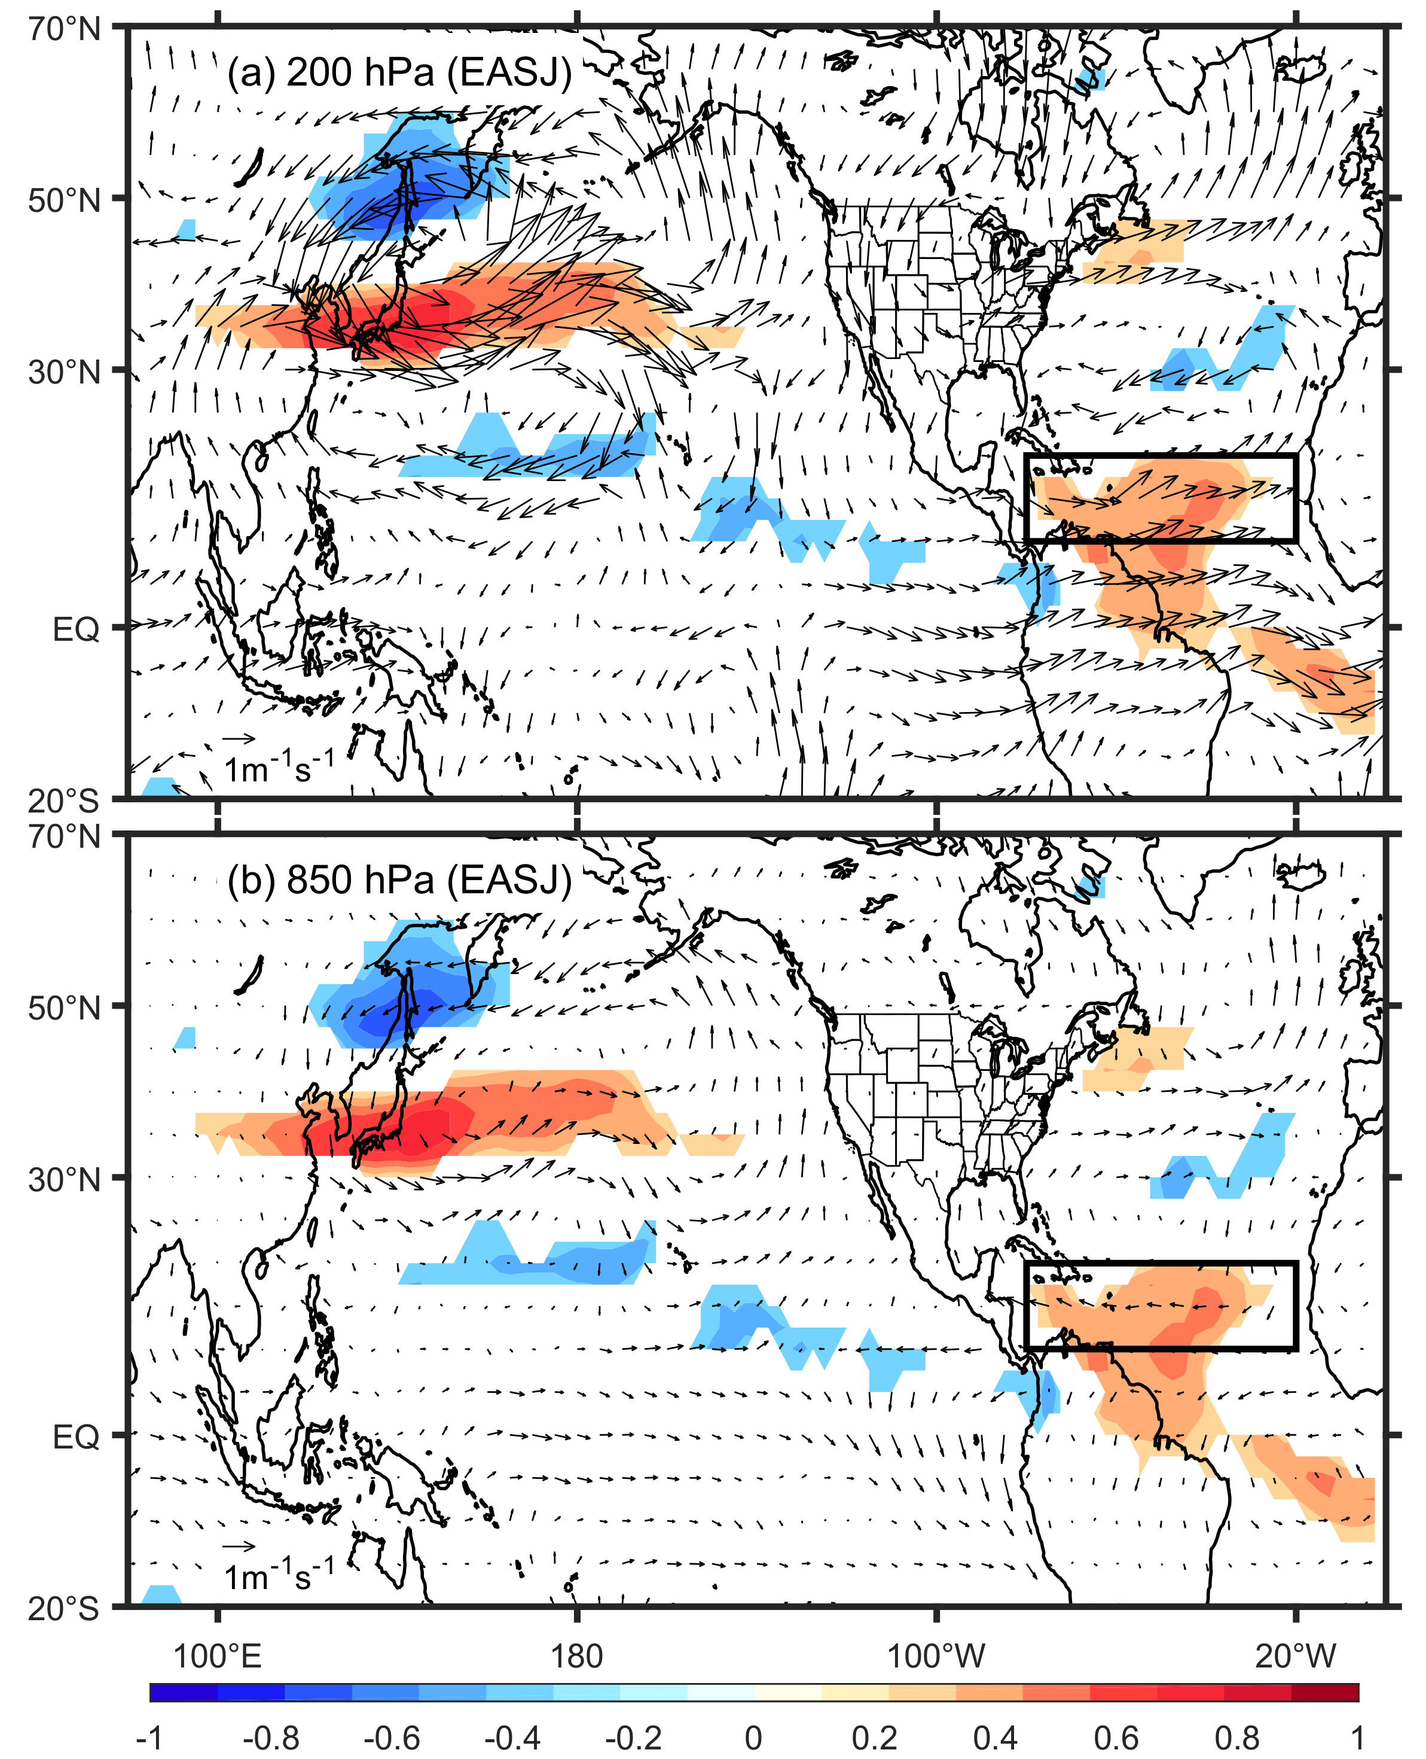
Figure S2. Regression of (a) 200 hPa and (b) 850 hPa winds in August-November (ASON) onto EASJ in July-October (JASO) with the linear fit to the Niño3.4 index removed. The shading represents the regions with significant correlation (at the 5% level) between ASON vertical wind shear and JASO EASJ. The black rectangle represents the Atlantic MDR (80°W-20°W, 10°N-20°N).
Figure S3. Regressed loading of sea surface temperature (shading, unit: °C) onto the EASJ index during July-October.

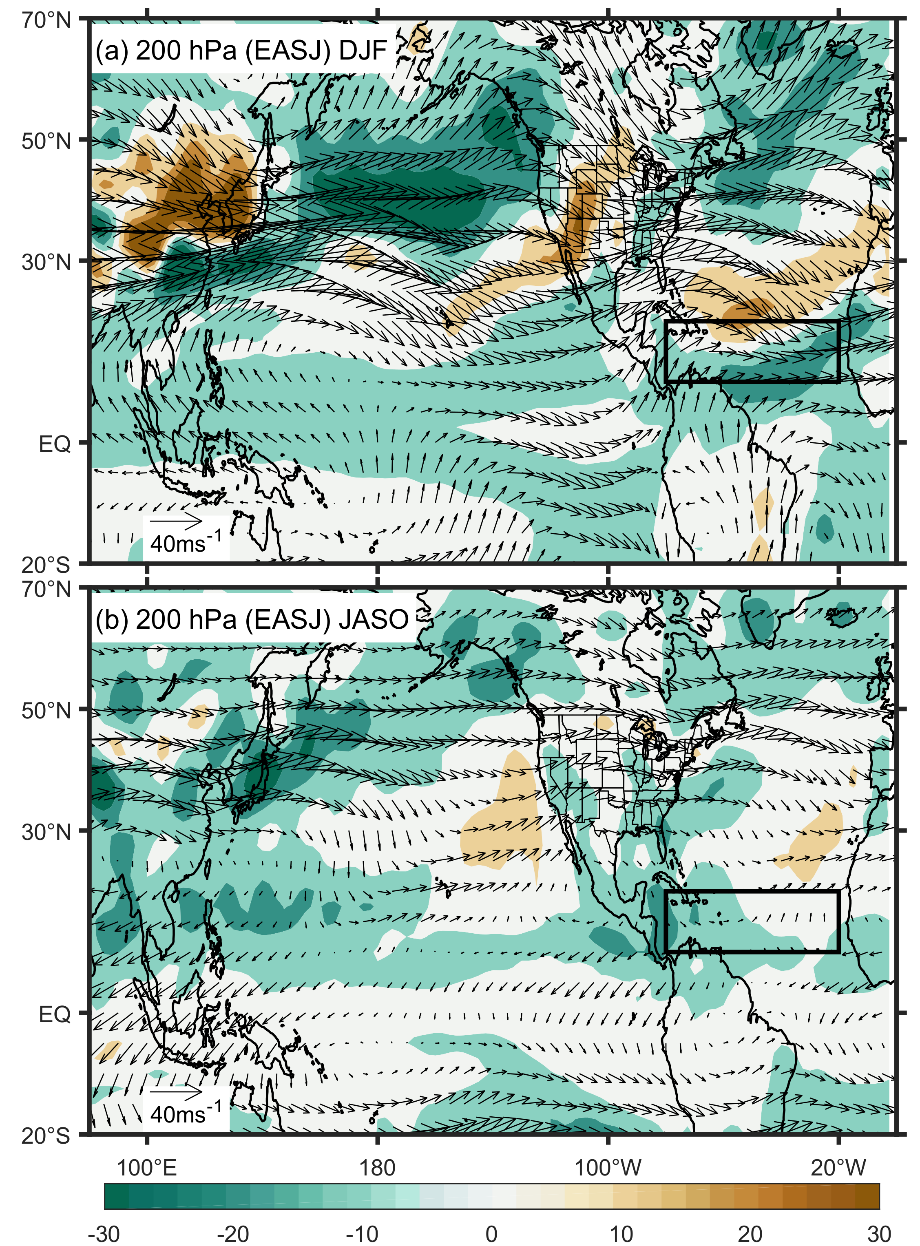
Figure S4. Climatology of Rossby wave source (shading, unit: ×10⁻¹¹ s⁻¹) and 200 hPa winds (vector: ms⁻¹) during (a) December-February (DJF) and (b) July-October. The black rectangle represents the Atlantic MDR (80°W-20°W, 10°N-20°N).

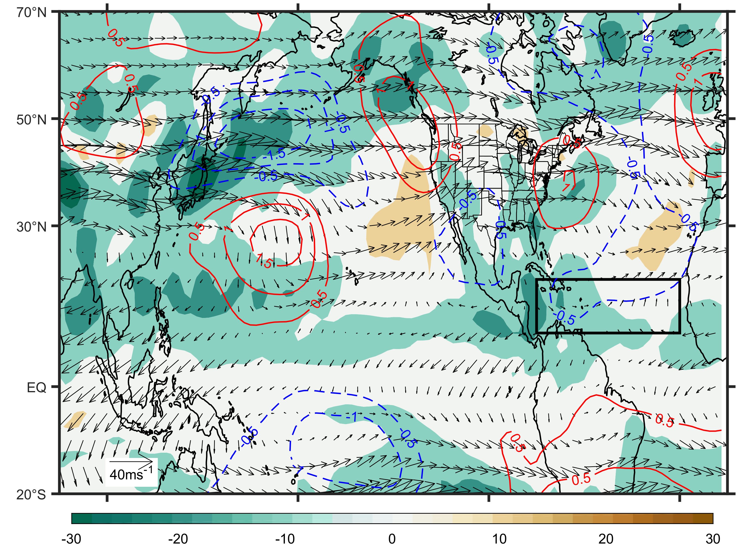
Figure S5. Climatology of 200-hPa wind fields (vector, ms⁻¹) and Rossby wave source (shading, ×10⁻¹¹ s⁻¹) during JASO of 1980-2018. Contours represent the regression of 200-hPa eddy stream function (zonal mean removed; ×10⁶ m²s⁻¹) during ASON onto the EASJ index (35°N-40°N) during JASO. The black rectangle represents the Atlantic MDR (80°W-20°W, 10°N-20°N).

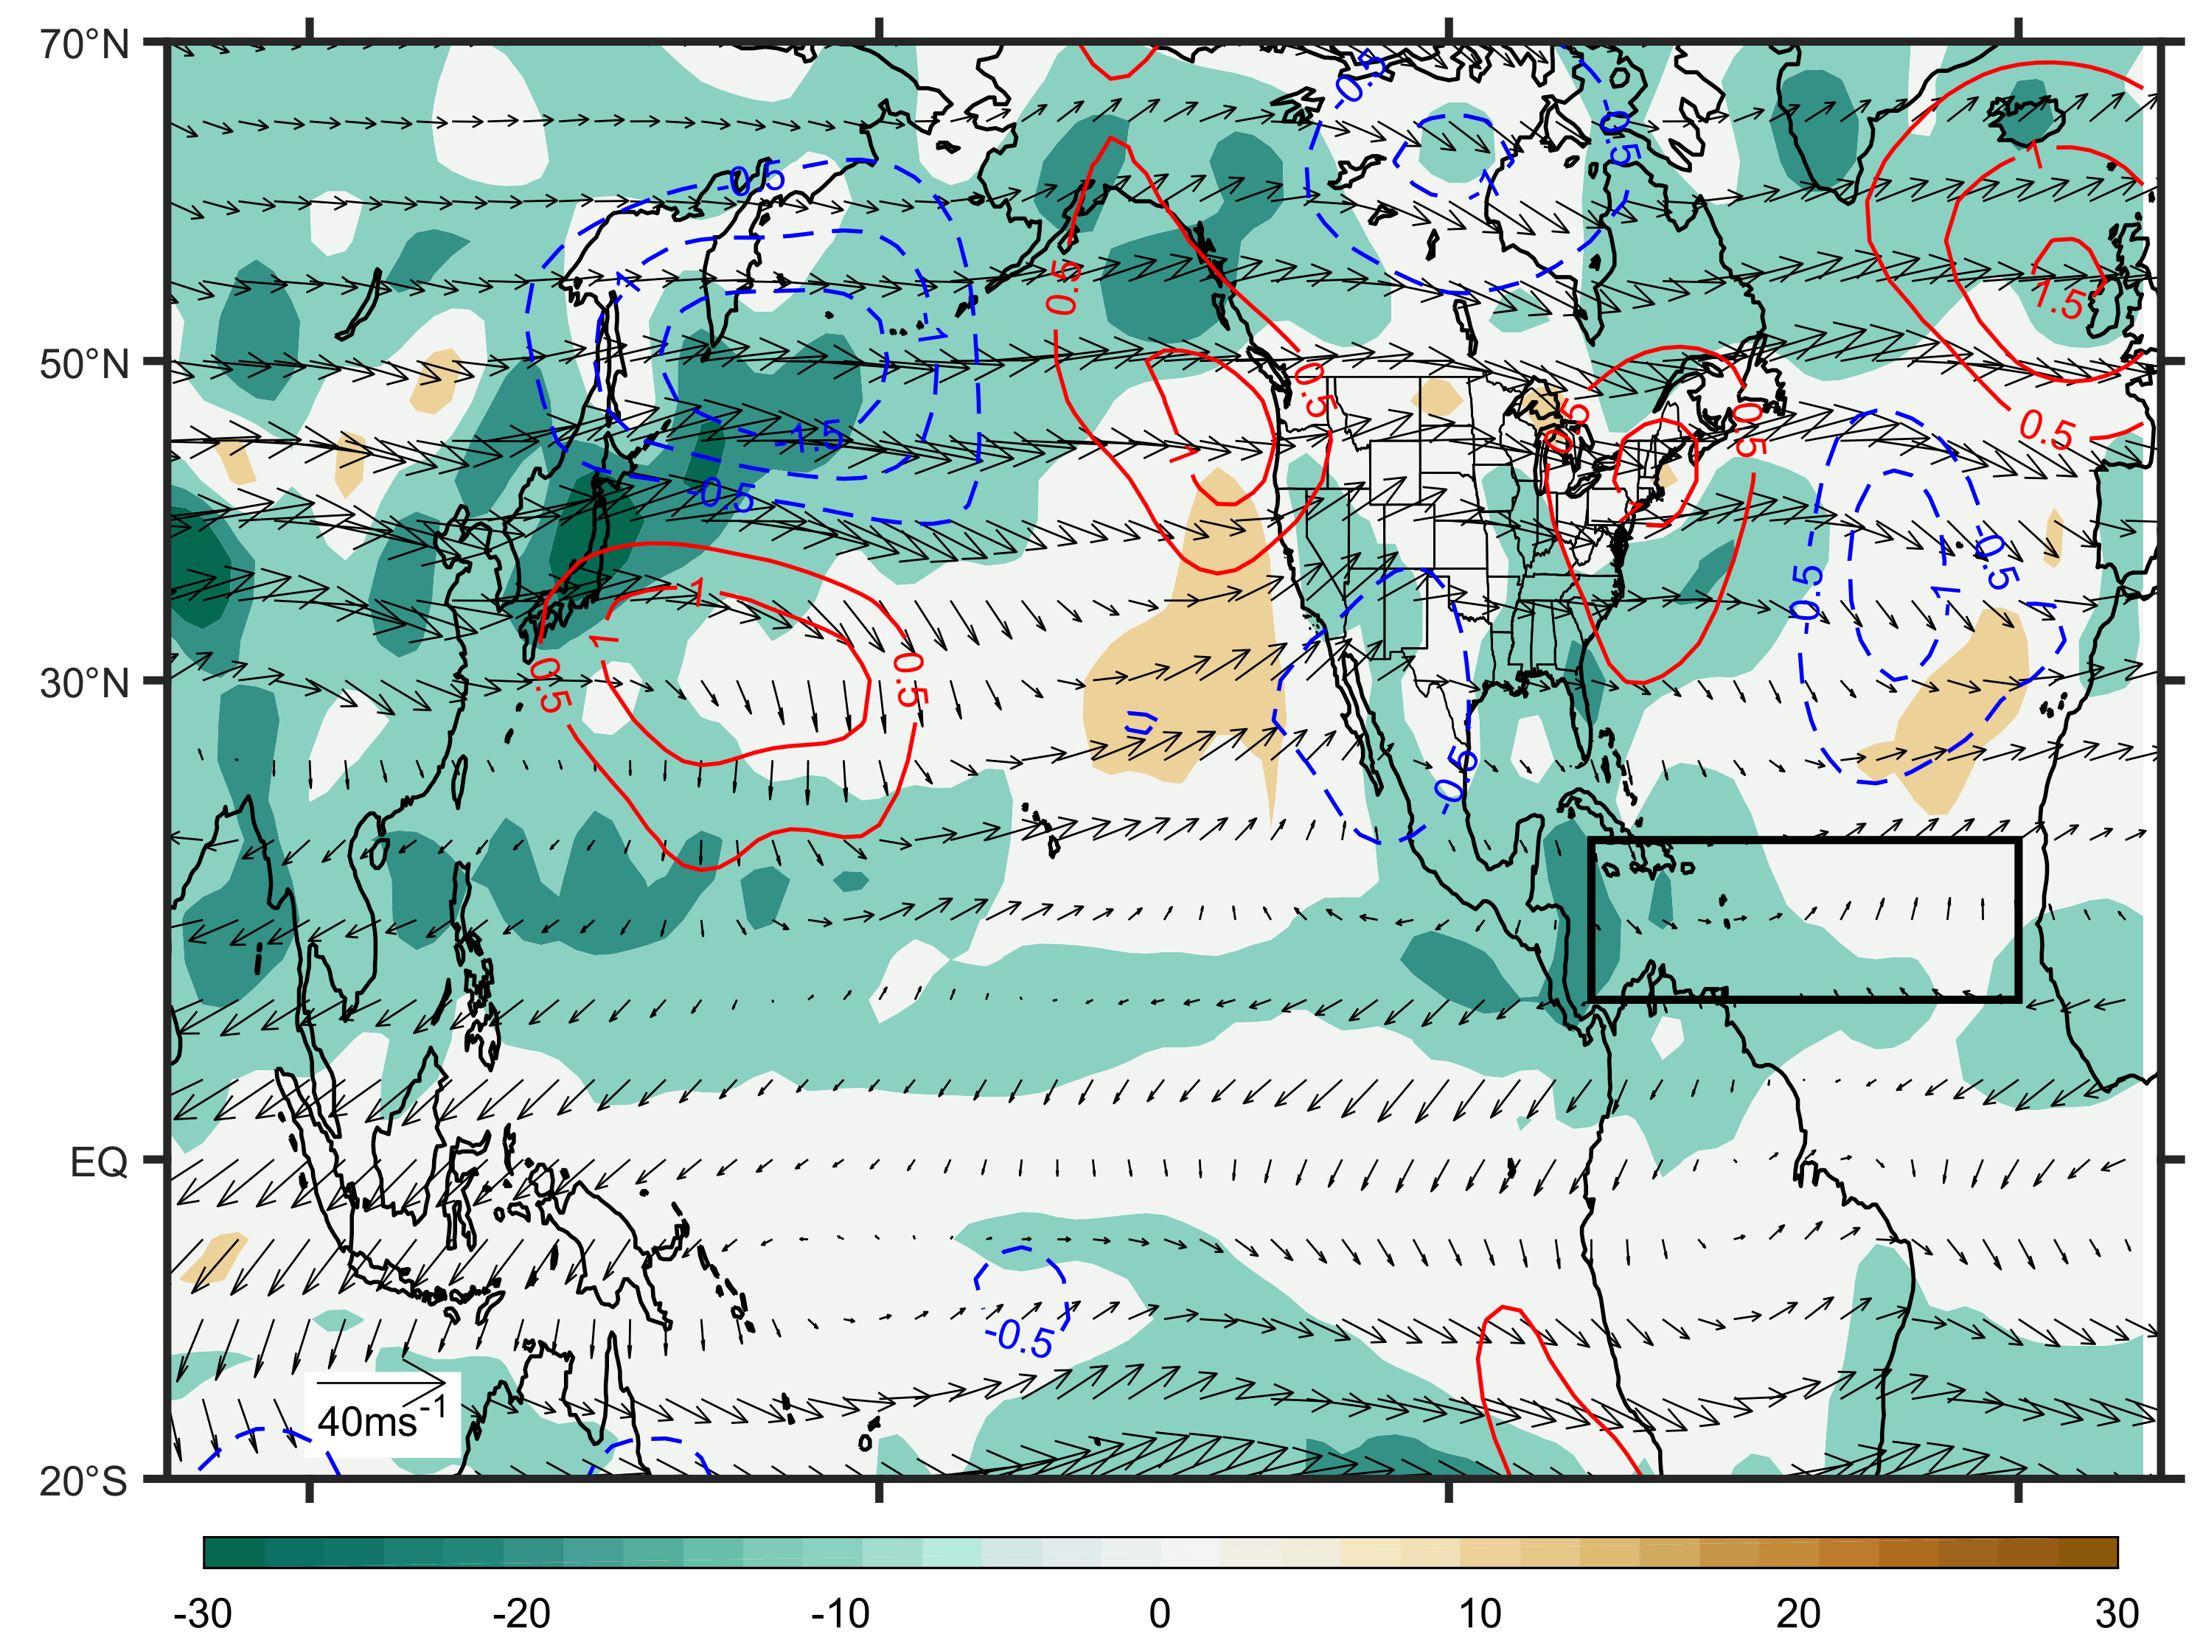
Figure S6. Climatology of 200-hPa wind fields (vector, ms⁻¹) and Rossby wave source (shading, ×10⁻¹¹ s⁻¹) during JASO of 1980-2018. Contours represent the regression of 200-hPa eddy stream function (zonal mean removed; ×10⁶ m²s⁻¹) during ASON onto the EASJ index (40°N-45°N) during JASO. The black rectangle represents the Atlantic MDR (80°W-20°W, 10°N-20°N).

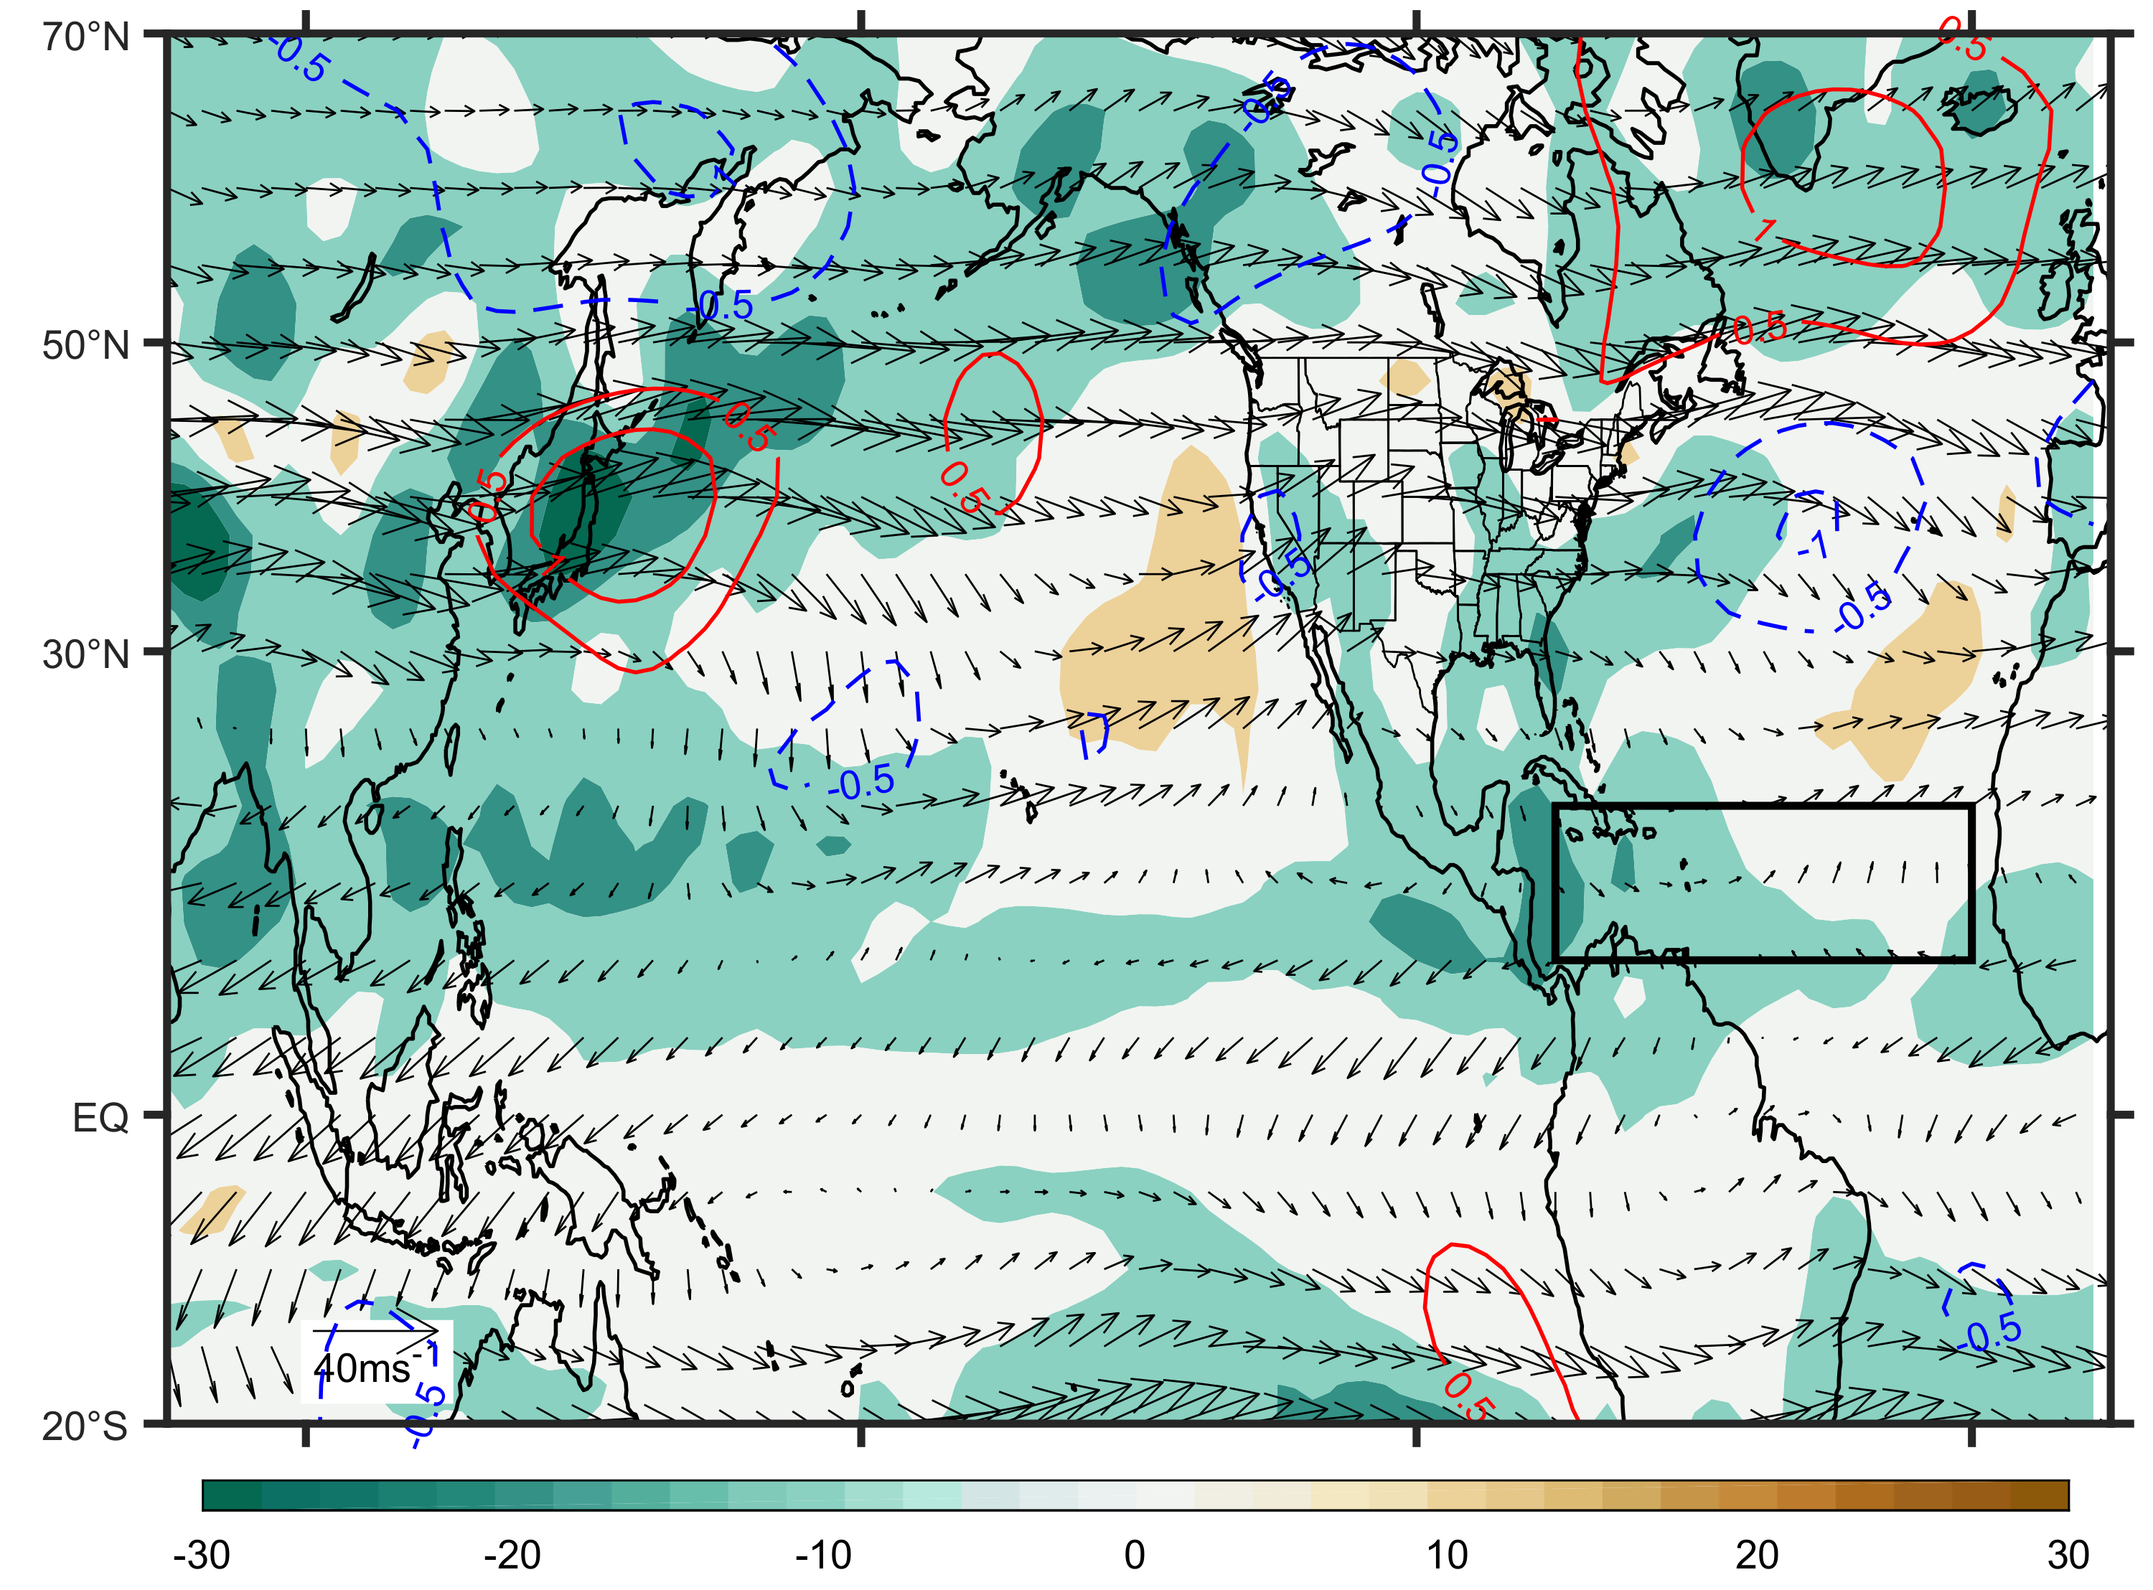
Figure S7. Climatology of 200-hPa wind fields (vector, ms⁻¹) and Rossby wave source (shading, ×10⁻¹¹ s⁻¹) during JASO of 1980-2018. Contours represent the regression of 200-hPa eddy stream function (zonal mean removed; ×10⁶ m²s⁻¹) during ASON onto the EASJ index (45°N-50°N) during JASO. The black rectangle represents the Atlantic MDR (80°W-20°W, 10°N-20°N).

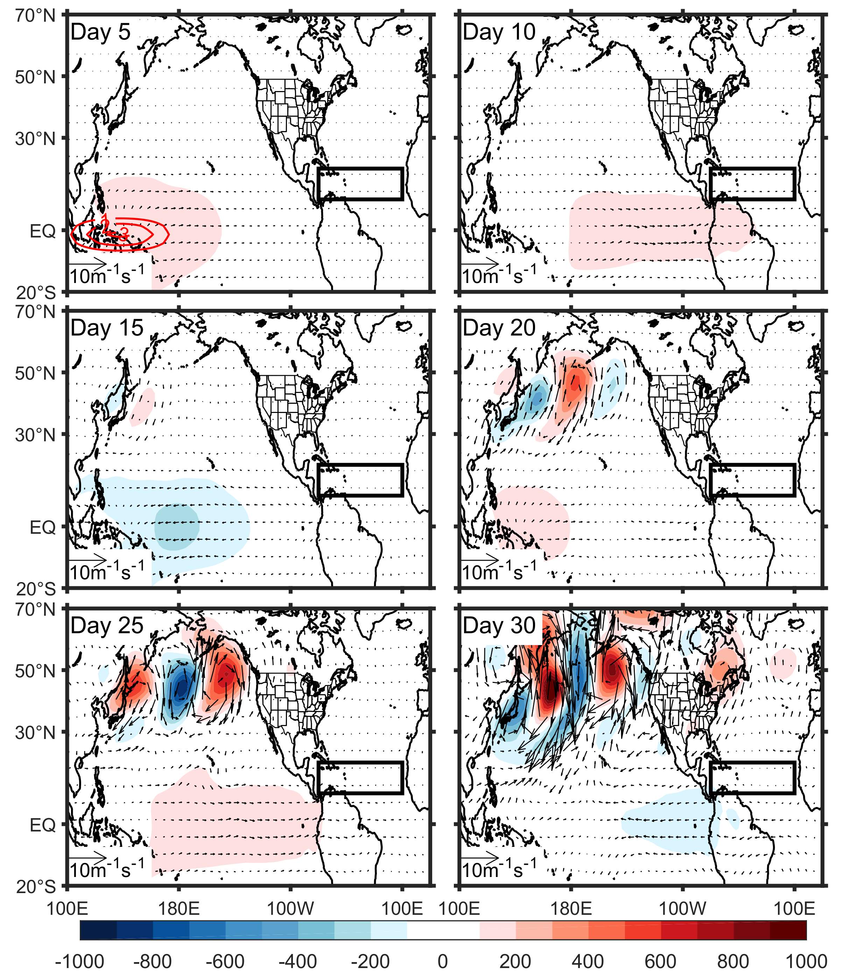
Figure S8. Responses of 200 hPa wind fields (unit: ms⁻¹) and 200-hPa geopotential height (unit: gpm) to the heating profile (3 K/day) prescribed in tropical western Pacific (red contours of the top left panel) using the mean state of July to October. The black rectangle represents the Atlantic MDR (80°W-20°W, 10°N-20°N).

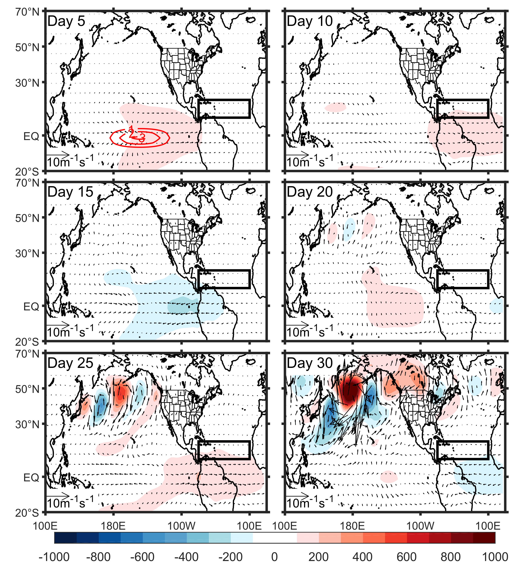
Figure S9. Responses of 200 hPa wind fields (unit: ms⁻¹) and 200-hPa geopotential height (unit: gpm) to the heating profile (3 K/day) prescribed in tropical central Pacific (red contours of the top left panel) using the mean state of July to October. The black rectangle represents the Atlantic MDR (80°W-20°W, 10°N-20°N).

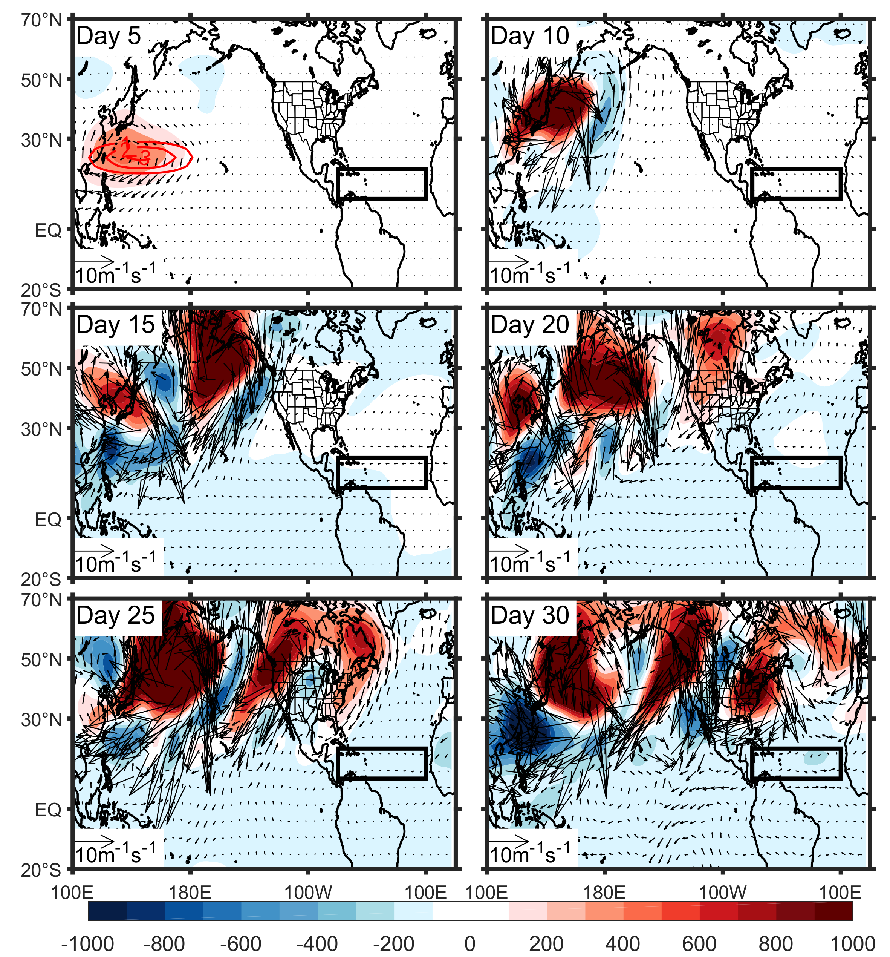
Figure S10. Responses of 200 hPa wind fields (unit: ms⁻¹) and 200-hPa geopotential height (unit: gpm) to the heating profile (3 K/day) prescribed in East Asia (red contours of the top left panel) using the mean state of July to October. The black rectangle represents the Atlantic MDR (80°W-20°W, 10°N-20°N).

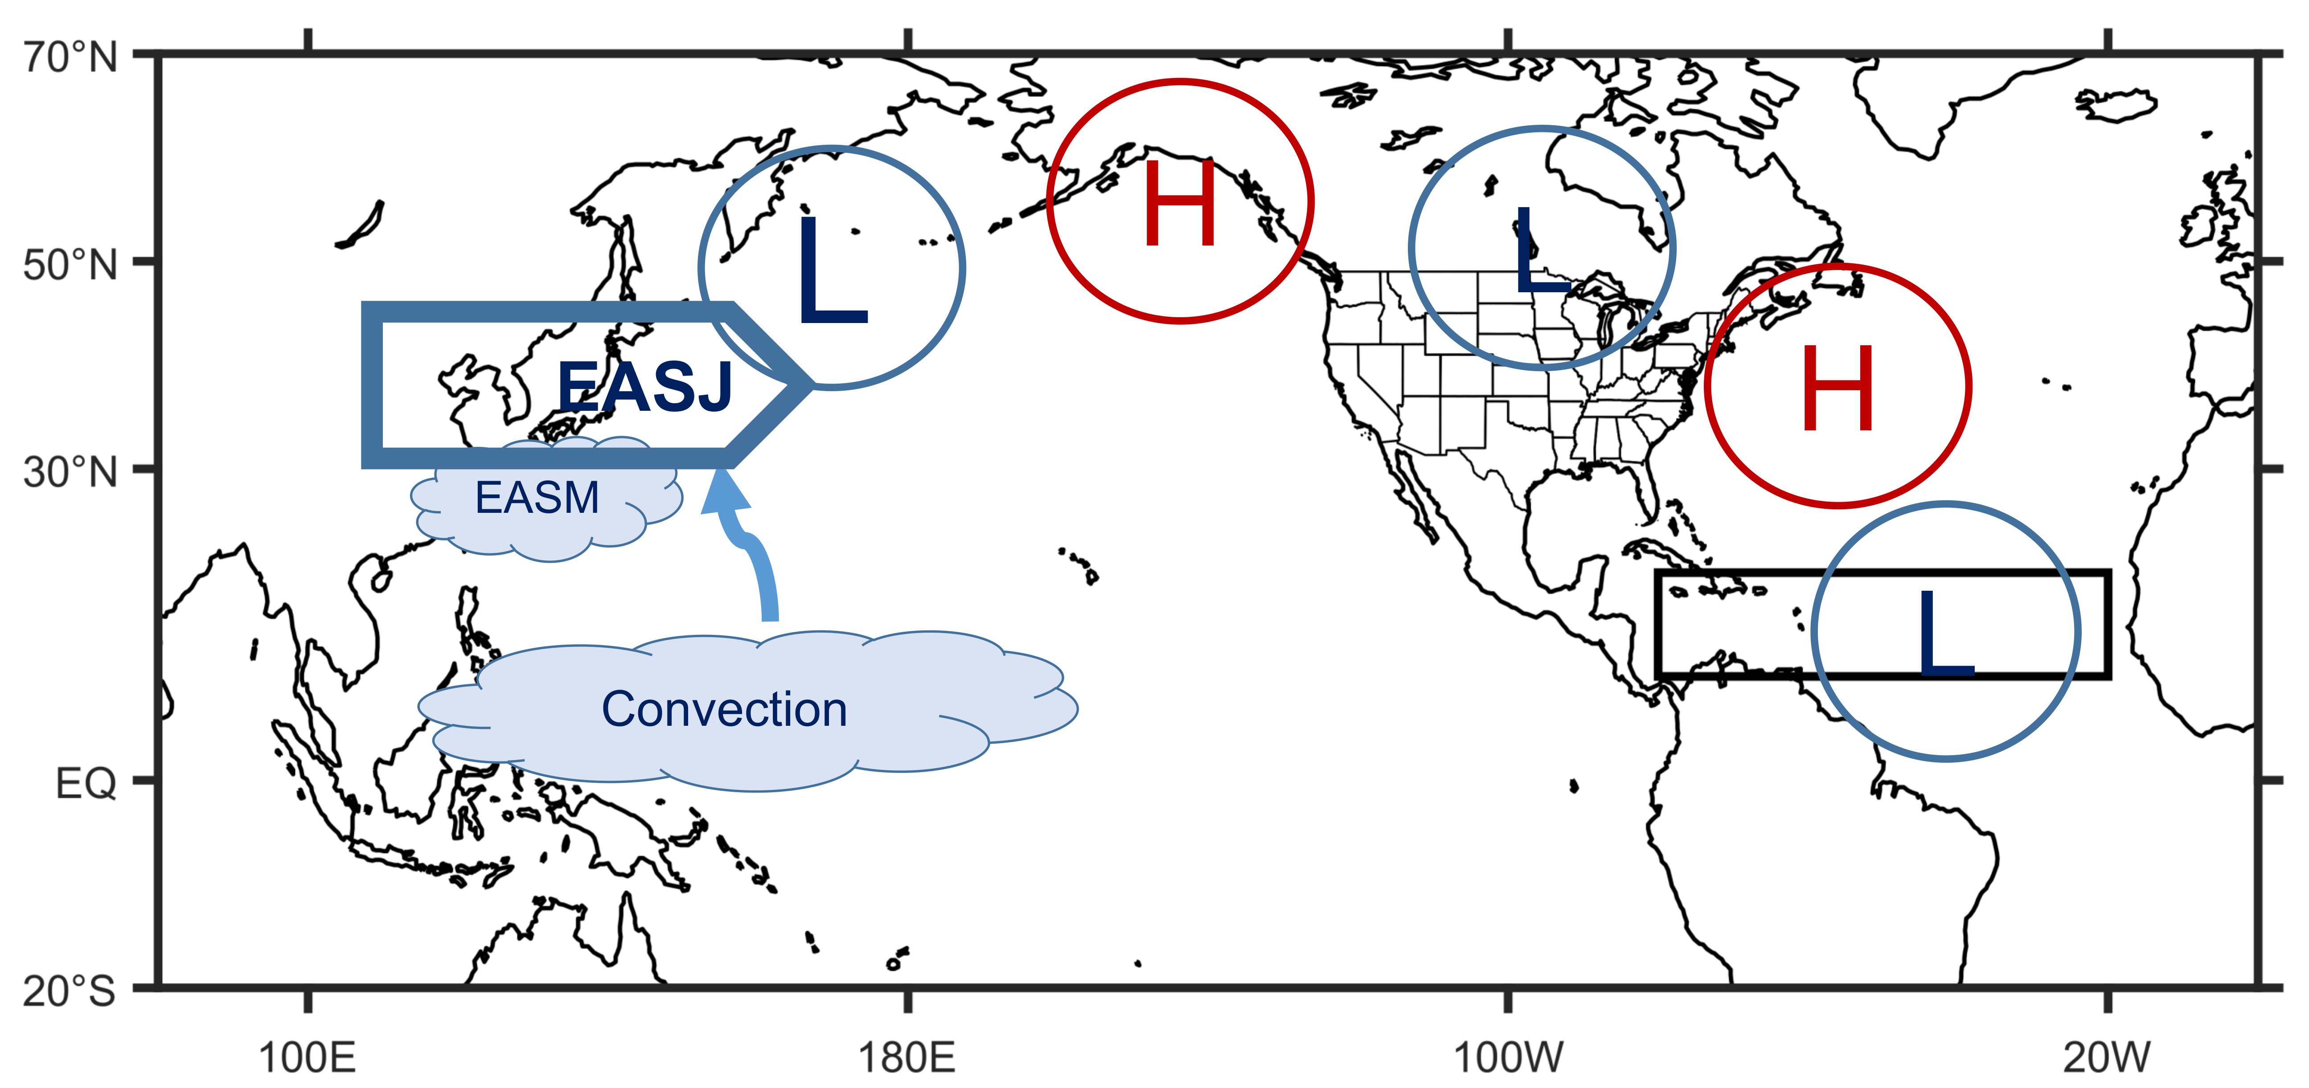
Figure S11. Schematic diagram for the impacts of EASJ on Atlantic TCs. “EASJ” represents East Asian Subtropical Jetstream, EASM represents East Asian Summer Monsoon, and “L” and “H” are “low” and “high” pressure systems at the 200 hPa level. The black rectangle represents the Atlantic MDR (80°W-20°W, 10°N-20°N).

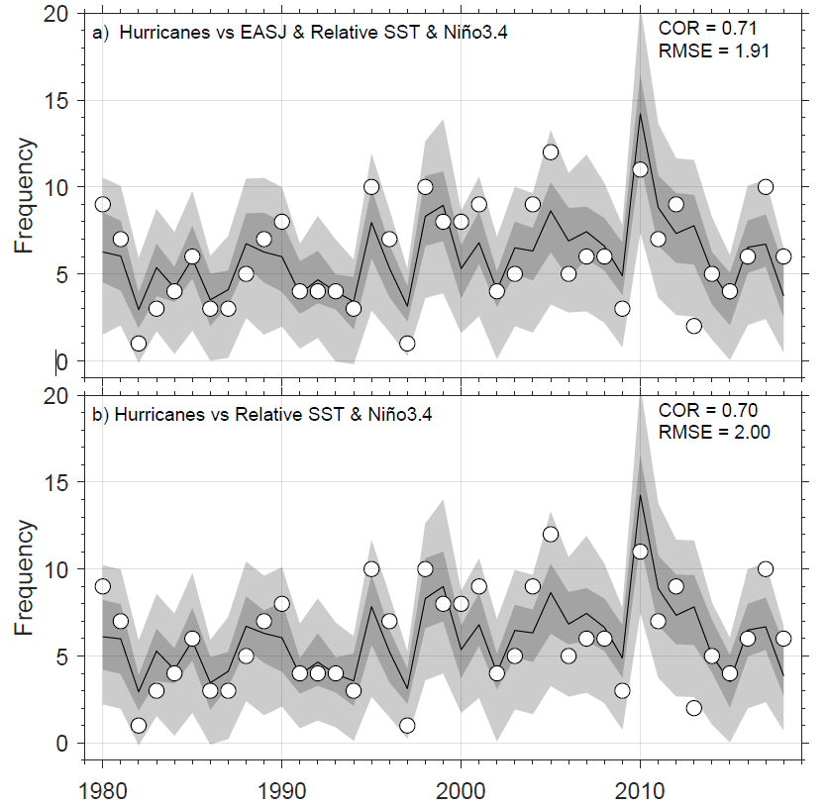
Figure S12. Fitted and observed frequencies of Atlantic hurricanes using predictors: (a) and EASJ, tropical relative SST and Niño3.4 and (b) tropical Atlantic SST and Niño3.4. The white circles represent the observations. The black line represents the median of the fitted Poisson distribution, while the dark (light) grey regions the 25–75th (5–95th) percentiles. Tropical Atlantic SST is defined as the sea surface temperature averaged over the Main Development Region (80°W-20°W, 10°N-20°N).

