Atmospheric Science Letters

Supporting Information for:

Twenty first century changes in Antarctic and Southern Ocean surface climate in CMIP6

Thomas J. Bracegirdle^{1*}, Gerhard Krinner², Marcos Tonelli³, F. Alexander Haumann^{4,1}, Kaitlin A. Naughten¹, Thomas Rackow⁵, Lettie Roach⁶, Ilana Wainer³.

¹British Antarctic Survey, Cambridge, UK.
²CNRS, Universite´ Grenoble Alpes, Institut des Ge´osciences de l’Environnement (IGE), Grenoble, France.
³Instituto Oceanogra´fico, Universidade de Sao Paulo, Brazil.
⁴Atmospheric and Oceanic Sciences Program, Princeton University, Princeton,
United States.
⁵Alfred Wegener Institute, Helmholtz Centre for Polar and Marine Research,
Climate Dynamics, Bremerhaven, Germany.
⁶Atmospheric Sciences, University of Washington, Seattle, WA, United States.

Contents of this file
Text S1
Figure S1

Text S1
This document contains Fig. S1, which shows additional information on wind changes associated with shifting and strengthening of the tropospheric westerly jet. The relevant methods and data sources are described in the main text.
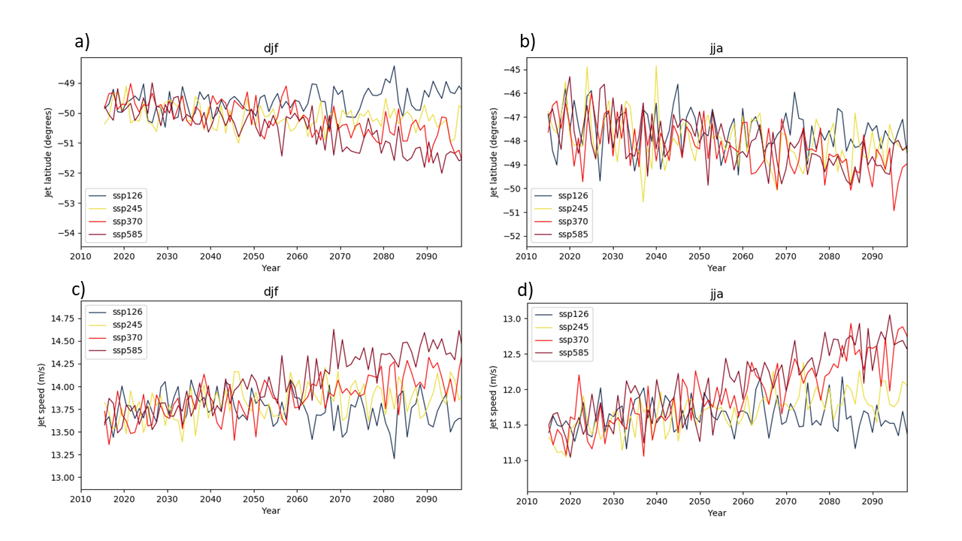
Fig. S1. Projected ensemble-mean summer (a, c) and winter (b, d) 21st century JLI (upper row) and JSI (lower row).

