SUPPLEMENTAL TABLES

Table S1. Satellite product and spatio-temporal resolution of environmental variables used in the modeling of California sea lion habitat selection.

Product | Source | Spatial Resolution | Temporal Resolution
Sea-Surface Temperature (SST) | GHRSST/Reynolds OI | 0.25° | 1-day
Chlorophyll-a (Chl-a) | SeaWiFS/MODIS | 0.0125° | 8-day
Mean sea level anomaly (SLA) | AVISO | 0.25° | 1-day
Eddy kinetic energy (EKE) | AVISO | 0.25° | 1-day
Seawinds | QuikSCAT/METOP ASCAT | 0.25° | 3-day
Bathymetry | ETOPO 1 | 1° | -
Distance to colony | ETOPO 1 | 1 m | -

SUPPLEMENTAL FIGURES

Figure S1. Sample comparison of actual sea lion trip (red) and correlated random walk pseudo-absences (blue), Tag ID: 2104007.

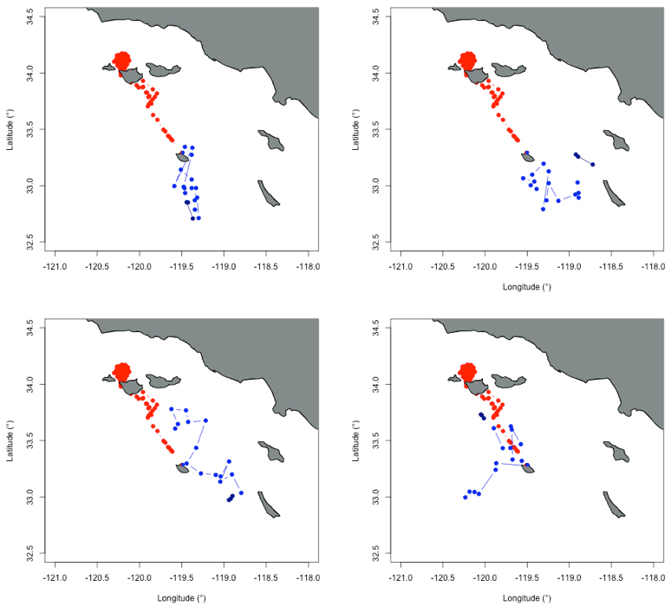

Figure S2. Receiver operating curves (ROCs) for final GAMM model run 40 times, with false positive on the x-axis plotted against the true positive on the y-axis. Average AUC = 0.91. A perfect ROC would have a false positive rate of 0 and a true positive rate of 1.

